Suliassat – Tamat oqartussaaqataanerat
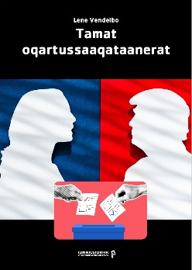
Atit

Atuannginninni
Atuakkap saqqaa qimerluualaaruk.
Atuakkap qulequtaa
________________________________________________________
Atuakkiortoq
________________________________________________________
Saqqummersitsivik
________________________________________________________

Atuakkap tunua qimerluualaaruk.
Atuagaq una sumut tunngava?
___________________________________________________________________________________________________________________________________________________________________________________________________________________________________________________________________________
Kalaallit Nunaanni tamat oqartussaaqataanerata atuutilerneraniit ukiut qassit ingerlareerpat?
_________________________________________________________________________________________

Suliassat – Tamat oqartussaaqataanerat

Atuarninni
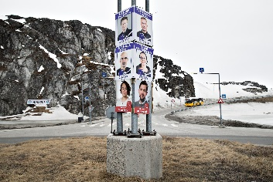
Atuarninni apeqqutinik akisassaqarputit.
Tamat oqartussaaqataanerat sunaava?
Tamat oqartussaaqataanerat qanoq isumaqarpa?
__________________________________________________________________________________________________________________________________________________________________
Qassinik ukioqaleraanni inersimasutut piginnaaneqartitaalertarpat? Aamma inersimasutut piginnaaneqartitaaleraanni susinnaappat?
__________________________________________________________________________________________________________________________________________________________________

Suliassat – Tamat oqartussaaqataanerat
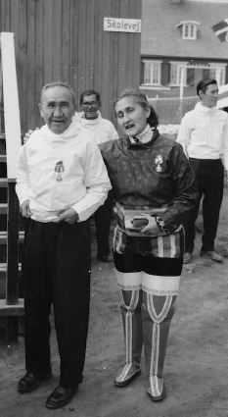
Arnat qinersisinnaalerput
Danmarkimi arnani siullersaalluni ministerinngortoq qanoq ateqarpa?
____________________________________________________________
Ukioq suna Kalaallit Nunaanni arnat qinersisinnaanngorsimappat?
___________________________________________________________
Kalaallit Nunaanni arnani siullersaalluni Landsrådimi qinigaasoq qanoq ateqarpa?
_________________________________________________________________

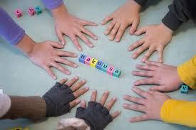
Meeqqat aamma tamat oqartussaaqataanerat
MIO suua? Qanga pilersinneqarpa?
_________________________________________________________________________________
Nakuusa suua? Qanga pilersinneqarpa?
_________________________________________________________________________________________

Suliassat – Tamat oqartussaaqataanerat
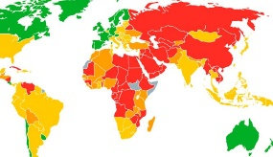
Nunarsuarmi tamat oqartussaaqataanerat
Kalaallit Nunaanni tamatoqartussaaqataanerat atuuppa?
_________________________________________________________________________________
Nunat tamat oqartussaaqataanerannik aqutsilluarnerit tallimat allattukkit
- _____________________________________________
- _____________________________________________
- _____________________________________________
- _____________________________________________
- _____________________________________________
Tamat oqartussaaqataanerata akerlia suua?
____________________________________________________

Qupp. 7 qimerluualaarukku nunat sungaartumik qalipaasikkat tassaapput ilaannakortumik tamat oqartussaaqataanerannik ingerlatsisut; nunamik taamatut ingerlasumik ataatsimik marlunnilluunniit taasaqarsinnaavit?
_________________________________________________________________________________
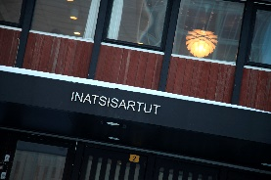
Suliassat – Tamat oqartussaaqataanerat

Kalaallit Nunaanni tamat oqartussaaqataanerat
Qanga tamat oqartussaaqataanerat Kalaallit Nunaanni aallarnisalerpa?
________________________________________________
Kalaallit Nunaanni tamat oqartussaaqataanerat atuutinngikkallarmat, suup nunap Kalaallit Nunaat aqunnikuuaa?
________________________________________________
“Paarsisut” qanoq isumaqarpat?
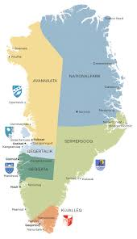
__________________________________________________________________________________________________________________________________________________________________
Kommunalbestyrelsi, inatsisartut folketingilu
Folketingimi ilaasortaatitat qassiuppat, kikkuuppallu?
__________________________________________________________________________________________________________________________________________________________________
Kalaallit Nunaanni kommuunit qassiuppat, qanorlu taaneqartarpat?
___________________________________________________________________________________________________________________________________________________________________________________________________________________________________________________
Inatsisartunut ilaasortat qassiuppat?
__________________________________________
Inatsisartut siulittaasuat ullumi kinaava?
__________________________________________
Suliassat – Tamat Oqartussaaqataanerat
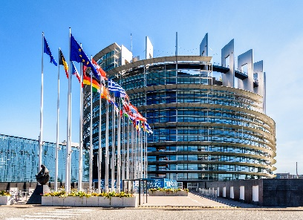
EU – europamiut tamat oqartussaaqataaffiat
Nunat qassit EU-mut ilaasortaappat?
____________________________________
EU naalisagaavoq, naalisarnagu qanoq allattarpaat?
_________________________________________________________________________________
Kalaallit Nunaat qanga EF-imut ilaasortanngoraluarpa?
____________________________________
Kalaallit Nunaat qanga EF-imut ilaasortaajunaarpa aammalu sooq?
__________________________________________________________________________________________________________________________________________________________________
EU-mi politikerit sunik inatsisiliortarnerannik allataqarit.
__________________________________________________________________________________________________________________________________________________________________
EU-p ataatsimiittarfissuata illorsua sumiippa?
_________________________________________________________________________________

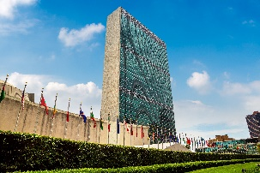
FN – nunarsuup tamat oqartussaaqataanera
FN-imi nunat ilaasortat katillugit qassiuppat?
_________________________________________
Qanoq akuttutigisumik naapittarpat?
_________________________________________________________________________________

Suliassat – Tamat Oqartussaaqataanerat

FN-ip suna siunertarivaa, qangalu pilersinneqarpa?
___________________________________________________________________________________________________________________________________________________________________________________________________________________________________________________
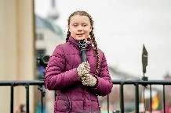
Kiffaanngissuseqartumik isummersinnaatitaaneq
Kiffaanngissuseqartumik isummersinnaatitaaneq qanoq isumaqarpa?
__________________________________________________________________________________________________________________________________________________________________

Tamat oqartussaaqataanerat tamaviaartoq
Europami nunat tamangajammik tamat oqartussaaqataanerannik aqutseriaaseqarput.
Suunuku nunat uani immikkoortumi pineqartut?
_________________________________________________________________________________

Sooruna taakku nunat suli tamat oqartussaaqataanerannik atuilinngitsut?
__________________________________________________________________________________________________________________________________________________________________
Suliassat – Tamat Oqartussaaqataanerat

Kisermaassillutik naalakkersuisut – Hviderusland aamma Korea Avannarleq
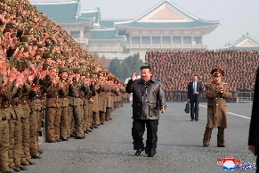
Kisermaassilluni naalakkersuineq qanoq isumaqarpa?
__________________________________________________________________________________________________________________________________________________________________
Nunarsuarmi kisermaassillutik naalakkersuisut kikkuuppat?
__________________________________________________________________________________________________________________________________________________________________
Europami nuna ataaseq kisermaassilluni naalakkersuisoqarpoq, nunami sorlermi?
_________________________________________________________________________________
Nunarsuarmi nunat matoqqanersaasa ilaat Korea Avannarliuvoq, aqutsisuat qanoq ateqarpa?
_________________________________________________________________________________
Sooruna Korea Avannarlermi inuiaqatigiit ikiorneqarusunngitsut?
___________________________________________________________________________________________________________________________________________________________________________________________________________________________________________________
Nunarsuarmi kisermaassillutik naalakkersuisunik allanik tusagaqarnikuuit?
__________________________________________________________________________________________________________________________________________________________________
Suliassat – Tamat Oqartussaaqataanerat

Atuareernerup kingorna

Atuakkami oqaatsit sorliit atorneqarpat? Ammalortuliigit.
qalipagaq tabeli nunap assinga titartakkat assit erseqqissaat
naleqqiffimmi titartagaq QR-kodi linkit allaaserisaq taallaq
allagaq oqaluttualiaq ilitsersuut nalunaarusiaq ullorsiutit

Suna atuakkami paasisaqarfiginerpaaviuk? Minnerpaamik marlunnik allataqarit.
- ___________________________________________________________________________
- ___________________________________________________________________________

