NAMMINERSORNERULLUTIK OQARTUSSAT/GRØNLANDS HJEMMESTYRE/GREENLAND HOME RULE

AEU-2
Tuluttut / Engelsk

Sygeeksamen

Piffissami nal. Ak/Tidspunkt.: 09.00 – 12.00
Ulloq misilitsiffik/Dato: Onsdag den 12. januar 2011
Ikiuutitut atorneqarsinnaasut / Hjælpemidler:
Oqaatsit / Ordbøger:
Qallunaatut – Tuluttut / Dansk - Engelsk
Tuluttut – Qallunaatut / Engelsk – Dansk
Kalaallisut – Qallunaatut / Grønlandsk – Dansk
Qallunaatut – Kalaallisut / Dansk - Grønlandsk

Misilitsinnerup sivisussusaa / Varighed: 3 timer

Atuartup aqqa / Kursistens navn: _____________________________________________________
Cpr. Nr. : ______________________________
Piareersarfik:___________________________

Nakkutilliisup atsiornera / Prøvevagtens navn: ____________________________
Piffissaq tunniussiffik / Tidspunkt for aflevering: __________________________

Describe the people in the picture and tell what they are doing
Beskriv personerne på billedet og fortæl, hvad de laver
Allaaseriuk inuit assilissamiittut qanoq isikkoqarnersut sulerinersullu oqaluttuariuk.

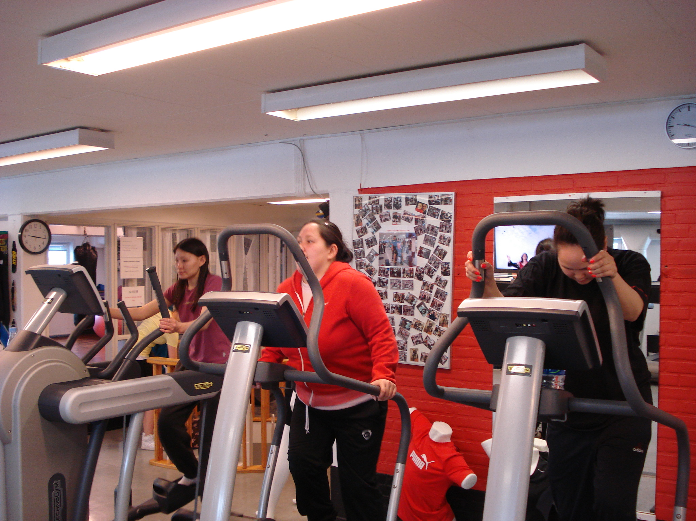

________________________________________________________________________________

___________________________________________________________________________________________________________

___________________________________________________________________________________________________________

___________________________________________________________________________________________________________

___________________________________________________________________________________________________________

___________________________________________________________________________________________________________

___________________________________________________________________________________________________________

___________________________________________________________________________________________________________

____________________________________________________________________________________________________________________________________________________________________________________________________________________________________________________________________________________________________________________________________________________________________________________________________________________________________________

______________________________________________________________________________________________________________________________________________________________________________________________________________________
__________________________________________________________________________________________________________________________________________________________________________________________________________________________________________________________________________________________________________________________________________________________________________________________________________________________________________________________________________________________________________________________________________________________________________________________________________________________________________________________________
__________________________________________________________________________________________________________________________________________________________________________________________________________________________________________________________________________________________________________________________________________________________________________________________________________________________________________________________________________________________________________________________________________________________________________________________________________________________________________________________________
_______________________________________________________________________________________________________________________________________________________________________________________________________________________________________________________________________________________________________________________________________________________________________________________________________________________________________________________________________________________________________________________________________________________________________________________________________________________________________________________________________________________________________________________________________________________________________________________________________________________________________________________________________________________________________________________________________________________________________________________________________________________________________________________________________________________________________________________________________________________________________________________________________________________________________________________________________________________________________________________________________________________________________________________________________________________________________________
Gap-filling
Put in the right word/indsæt det rigtige ord/oqaaseq eqqortoq ikkuguk.

Am - are - is
Many people _______ eating too much. Maybe they _______ unhealthy because they eat the wrong things. My two sisters _________ very particular about their food. I ________ satisfied when I have enough food, so _______ my brother. We ________ both lucky to be in good health. Everybody _______ interested in having a good life. Some people _________ getting sick from eating bad food. My brother_______ interested in sports . He _____ a healthy boy. My parents _______ working out in a fitness centre. We ____ going to spend our holidays walking and camping in Norway. My mother and my father _________ looking forward to our vacation, because we ________ doing something together.

Have – has - had
I _______ never been camping before. My brother _________ never been in Norway. Last year we_________ not thought about eating healthy food. Then my father ______ a small stroke. That ________ changed our lives. Now we ________ to eat good food, because my parents ______ decided to live that way. This year our school ______ promised us to serve better food. Earlier we never ________ any vegetables. Last year I ________ no ideas about good and bad food, but this year I _________ learned a lot about food. My sisters and I _____ decided to eat healthy food like our parents from now on.

Write down the right form of the verb in the Present Tense / skriv den rigtige form af verbet I nutid / oqaluut “maannakkut” eqqortoq allaguk

(to eat) My brother ___________ a lot. (to walk) My sisters ________ a lot. (to like) I _________ junk food. (to live) We __________ in a modern world. (to be) My father___________ older than my mother. (to be) We ________five persons in my family. (to hate) My mother ________ junk food. (to love) She ______vegetables. (to say) My father _______ it is important to eat six times a day

Put in the right word / indsæt det rigtige ord / oqaaseq eqqortoq ikkuguk
was told talked read might drank asked did thought had

I have _______ an article about diabetes. It ______not funny reading. I _______ not know about all the bad things that_________ happen to people with diabetes. I __________ to a young man with diabetes. I ________him about his life. He _____ me that he never _________ any alcohol, and that he _______ to work out every day. He had ________ a lot about how to live with his diabetes.

Put the words in the right order / sæt ordene I den rigtige rækkefølge / oqaatsit eqqortumik tulleriiaakkit.

like I food

buy lot vegetables We a of

sister My to likes junk food eat

like I fruit

are in forward We to looking Norway our vacation

Read and understand.
Read the text and answer the questions /læs teksten og besvar spørgsmålene/oqaasertai atuakkit apeqqutillu akillugit.

Diabetes in Greenland
Studies in Greenland back in the 1960s have shown that diabetes was almost non existent at that time. Therefore it was a big surprise when a recent examination showed that 8 % of the adult Greenlanders have diabetes.
In 1999 people in three different places in Greenland were examined. The result was that 10% of these people had diabetes. Doctors think that many Greenlanders get diabetes nowadays because of the way the population in Greenland live and because of the food they eat. Today many people eat food imported from Europe, and there can be a lot of fat and sugar in some of these products.

Was diabetes a problem in Greenland in the 1960s?

What did the recent examination in Greenland show?

Who was examined in 1999?

What did the examinations in 1999 show?

Why do doctors think that Greenlanders get diabetes nowadays?

What sort of food do we eat today?

What do we drink?

Write a story

Answer both A and B:
A. Write a story about what you think is happening in the picture
B. Tell about your own family traditions

Besvar både A og B:
A. Skriv en historie om, hvad du mener, der sker på billedet.
B. Fortæl om dine egne familietraditioner

A aammalu B akikkit:
A. Assiliaq najoqqutaralugu oqaluttualiorit.
B. Illit ilaqutanni ileqquliunneqarsimasunik oqaluttuarit























































































































































