NAMMINERSORNERULLUTIK OQARTUSSAT/GRØNLANDS HJEMMESTYRE/GREENLAND HOME RULE

AEU-2
Tuluttut / Engelsk

Piffissami nal. Ak/Tidspunkt.: 09.00 – 12.00
Ulloq misilitsiffik/Dato: Onsdag den 1. december 2010
Ikiuutitut atorneqarsinnaasut / Hjælpemidler:
Oqaatsit / Ordbøger:
Qallunaatut – Tuluttut / Dansk - Engelsk
Tuluttut – Qallunaatut / Engelsk – Dansk
Kalaallisut – Qallunaatut / Grønlandsk – Dansk
Qallunaatut – Kalaallisut / Dansk - Grønlandsk

Misilitsinnerup sivisussusaa / Varighed: 3 timer

Atuartup aqqa / Kursistens navn: _____________________________________________________
Cpr. Nr. : ______________________________
Piareersarfik:___________________________

Nakkutilliisup atsiornera / Prøvevagtens navn: ____________________________
Piffissaq tunniussiffik / Tidspunkt for aflevering: __________________________

Describe the people in the picture and tell what they are doing
Beskriv personerne på billedet og fortæl, hvad de laver
Allaaseriuk inuit assilissamiittut qanoq isikkoqarnersut sulerinersullu oqaluttuariuk.

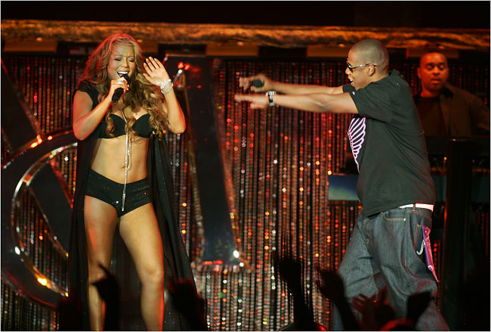

________________________________________________________________________________

___________________________________________________________________________________________________________

___________________________________________________________________________________________________________

___________________________________________________________________________________________________________

___________________________________________________________________________________________________________

___________________________________________________________________________________________________________

___________________________________________________________________________________________________________

___________________________________________________________________________________________________________

__________________________________________________________________________________________________________________________________________________________________________________________________________________________________________________________________________________________________________________________________________________________________________________________________________________________________________________________________________________________________________________________________________________________________________________________________________________________________________________________________
__________________________________________________________________________________________________________________________________________________________________________________________________________________________________________________________________________________________________________________________________________________________________________________________________________________________________________________________________________________________________________________________________________________________________________________________________________________________________________________________________
__________________________________________________________________________________________________________________________________________________________________________________________________________________________________________________________________________________________________________________________________________________________________________________________________________________________________________________________________________________________________________________________________________________________________________________________________________________________________________________________________
_______________________________________________________________________________________________________________________________________________________________________________________________________________________________________________________________________________________________________________________________________________________________________________________________________________________________________________________________________________________________________________________________________________________________________________________________________________________________________________________________________________________________________________________________________________________________________________________________________________________________________________________________________________________________________________________________________________________________________________________________________________________________________________________________________________________________________________________________________________________________________________________________________________________________________________________________________________________________________________________________________________________________________________________________________________________________________________
Gap-filling
Put in the right word/indsæt det rigtige ord/oqaaseq eqqortoq ikkuguk.

Am - are - is
Many people _______ interested in famous people. I _______ interested in Mariah Carey. My two sisters _________ looking forward to the next concert, where there _________ going to be thousands of visitors. My brother_______ only interested in sports . He_____ watching television all the time. My parents _______ going to New York this summer. Everybody ______ visiting the theatres on Broadway. We ____ going to spend our holidays with friends. My mother and my father ____ looking forward to their vacation, because the children ________ staying at home.

Have – has - had
I _______ never been to a big concert. My brother _________ never been to a concert at all. Last year we_________ a famous teacher in English, he ______ a funny accent. This year our school ______ promised us to invite another famous person . Earlier we never ________ any visitors Last year I ____ no idols, but this year I _________ several. My sisters and I _____ to save a lot of money. Last year I ______ a job. Concert tickets _______ always been very expensive, and I _______ decided to attend at least three concerts this year.

Write down the right form of the verb in the Present Tense / skriv den rigtige form af verbet I nutid / oqaluut “maannakkut” eqqortoq allaguk

(to listen) My brother never ___________ to me. (to talk) My sisters ________ a lot. (to like) I _________ music. (to live) We __________ in the country. (to be) My sister___________ two years younger than me. (to be) We ________five persons in my family. (to hate) My father ________ music. (to love) He ______to travel. (to say) He _______ it is important to meet other people.

Put in the right word / indsæt det rigtige ord / oqaaseq eqqortoq ikkuguk

was spent had were did went drank decided found hated dropped

Last year I _______ a boyfriend. It ______nice. We _______ not go to concerts. We ______ a lot of time together. We ______ to a lot of parties, and we ________ too many beers. At last I ________him, because I ___________ to change my life. My mother and father ______ happy that I ________ a new lifestyle. My brother also __________ my boyfriend.

Put the words in the right order / sæt ordene I den rigtige rækkefølge / oqaatsit eqqortumik tulleriiaakkit.

like I music

spend lot money We a of

sister My to like and concerts I to go

like I actresses

are forward looking meeting to We Mariah Carey.

Read and understand.
Read the text and answer the questions /læs teksten og besvar spørgsmålene/oqaasertai atuakkit apeqqutillu akillugit.

Mariah Carey
Mariah Carey is a famous American singer, songwriter, record producer and actress. She was born on March 27, 1970 in New York. She was the third and youngest child in the family. Her mother is a former singer and song teacher.
Mariah’s parents divorced when she was three years old. Her mother had to work a lot to support her little family. Mariah started to sing when she was three years old, and her mother gave her song lessons.
In 1997 Mariah started to take professional acting lessons and we all know how famous she has become today.

What is Mariah’s profession?

How old is she?

Where was she born?

What did her mother do?

Who did teach Mariah to sing?

How old was Mariah, when she started to sing?

What do you know about Mariah Carey?

Write a story

Answer both A and B:
A. Write a story about what you think is happening in the picture
B. Tell about a famous person you like

Besvar både A og B:
A. Skriv en historie om, hvad du mener, der sker på billedet.
B. Fortæl om en berømt person du godt kan lide

A aammalu B akikkit:
A. Assiliaq najoqqutaralugu oqaluttualiorit.
B. Inuk tusaamasaq nuannarisat pillugu allaaserinnigit.























































































































































