Piareersarfik
Kalaallisut misilitsinneq AEU 1 (Atuuttussaq / Ordinær)

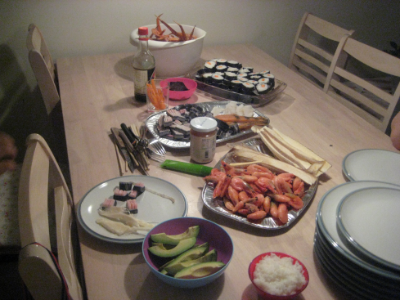
Suliassiissutit sisamaapput: Tamarmik akineqassapput
Ulloq misilitsiffik: 27. maj 2011
Piffissami nal. Ak. 09.00-12.00

Ikiuutissat: Ordbogit: Oqaatsit – kalaallisut/qallunaatut
Misilitsinnerup sivisussusia/ Varighed 3 timer

Atuartup aqqa/ Elevens navn:________________________________________________________________
Cpr.nr.:_________________________________________
Piareersarfik:_______________________________________

Nakkutilliisup atsiornera: Prøvevagtensunderskrift:________________________________________________________
Piffissaq tunniussiffik / Tidspunkt for aflevering:______________________________________________________
Suliassaq 1
- Allaaserisaq atuaqqissaaruk.
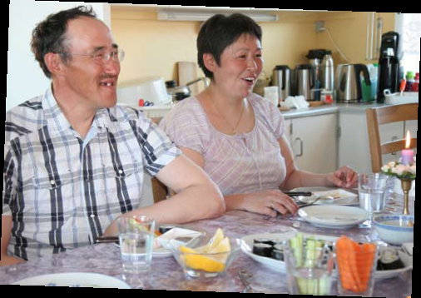
Ukioq tamaat imminnut pilersorput
”Taamaalluta aasat ilaanni aalajangerpugut eqalunniarniarnata, kiattunut feeriarniaratta. Utereersimalerlutali misigilerpugut tamanna pissusissamisuunngitsoq, oqallaataalu piareersapallariarluta aallarpugut. Tassa taama pilineq pinngitsoorsinnaajunnaartigilersimavarput.” Ilaqutariit Olsennikkut, Aasiammiut, oqarput.

Ilaqutariit Olsennikkut tassaapput, anaanaasoq Karla, ataataasoq Frantz kiisalu meeraat inuusuttut marluk Sikkersoq Angutinnguarlu.
Frantzi aalisarnermik piniarnermillu inuutissarsiuteqarpoq, sunngiffimminilu angalajuartarluni. Karla ukiorpassuit Pisiffimmi allaffimmiuusimalluni, maanna kommunemi atorfeqarpoq.
”Ukioq naallugu kalaaliminernik immitsinnut pilersorpugut. Ukiup qanoq ilinera naapertorlugu piniagassat malinnaaffigaavut. Maajimi ammassaat takkukkaangata ammassisarpugut, panertitsillutalu. Juulimi eqaluit takkukkaangata eqalunniartarpugut, tarajorteraluta kiisalu pujoorilluta. Sila nillertikkiartuleraangat aalisakkat sammiunnaarlugit, tuttunut umimmannullu (pisassaqarsimagaangatta) saattarpugut, aamma paarnanik, kimmernanik kigutaarnanillu nuniattaqaagut. Ukiukkut qilalukkat takkukkaangata taakununnga saattarpugut. Puisit aamma mamarilluaratsigit pinngitsoorumaneq ajorpavut.” Frantz oqaluttuarpoq. Taassuma imminut pilersorneq angajoqqaaminit kingornussimavaa, piniarfinnaaqarporlu.
“Nassuttuup paavanut, taseq ikaarlugu aavariartarpugut. Tuttut tassani pisaat immikkorluinnaq mamaqartarput, immaqa nerisaasa isugutannerat peqqutaalluni.” Oqarpoq.

Meeqqat angalaarullugit qatsussitingajappaat
Ukiut tamaasa ilaqutariit eqalunniartarput. Tarajorterisarput pujoorillutillu.
“Tupertarpugut. Eqaluillu paarnaqutinik pujoortarlutigit. Ukiut tamaasa taamaaliornissaq pinngitsoorsinnaajunnaarsimavarput. Meeqqat mikisut siullermik eqalunniaratta assorsuaq angerlarsersimavunga, immaqa inuit akornanniinnginnera pillugu. Kisianni angerlarama paasivara inuit qimalaarlugit inuuneq qanoq qasuernartigisoq. Taamanili ukiut tamakkerlugit eqalunniartarpugut,” Karla oqaluttuarpoq.
Ilaqutariit sunngiffimminni umiatsiamik angalaartuartarput.
“Tassa meeqqat meeraaneranniit angalaaruttuartarpagut. Qatsussitingajavissimagunarpagut,” Frantz illarlaarluni oqarpoq. Aamma qimmeqarsimagaluarput, ukiukkut qimussertarlutik.
“Ukioq kingulleq sikunngivippugut. Taamaammallu aalajangerpugut qimmeerunniarluta, tassami qimmit atorlugit ajussanngikkaluarpoq silalli pissusaata allanngornerisa kingorna sulinaannalermata toqorartinniarlugit aalajangerpugut. Ajoraluarpoq, kisianni tassa pissutsit taamaapput.” Frantz oqarpoq.
Nammineq pisat nalitoqaat
Ukiup ingerlanerani ilaqutariit pisaminnik ilaquttaminnut utoqqarnullu pajuttortarput.
“Tamanna ileqquujuarsimavoq, uagullu aamma ileqqoraarput. Pajulluni qujasut tuppallernartaqaat nuannaajallannartarlutillu.” Ilaqutariit oqarput.
Pisaminnik aamma panertitsineq ileqqoraat.
“Qilalukkat neqai niviugaqalinnginnerani panertittarpagut, ammassaat tuttut umimmaallu aamma panertillugit mamareqaavut. Nerisassat qeritittarpavut, ukiullu ingerlanerani tigullattaallugit nerisarisarlutigit.”
Ilaqutariit ilaquttaminnik kammalaatiminnillu neriartoqqusineq aamma piutigaat.
“Neriartoqqusillattaasaqaagut. Taamaaliorniaraangatta nammineq pisatsinnik igasarpugut. Tassami nammineq pisat nalituutut isigaagut, sassaalliutiginissaallu assut orniginartittarlugu. Tassami nammineq pisanik sassaalliineq qamuuna nuannertarpoq tanngassimaarnarlunilu,” Ilaqutariit isumaqarput.
Tigulaariffik: Aminnguaq Dahl Petrussen: Sila- ilaqutariinnut atuagassiaq. Ukiaq 2010.

Ukioq tamaat imminnut pilersorput
Suliassaq 2
- Allaaserisamit apeqqutit akikkit.
- Ilaqutariinuku aasat ilaanni susimasut?
________________________________________________________________________________________________________________________________________________________________________________________________________________________________________________________________________________

- Ilaqutariit aasaanerani suut piliarisarpaat?
________________________________________________________________________________________________________________________________________________________________________________________________________________________________________________________________________________

- Ukiup ingerlanerani ilaqutariit suut piniagarisarpaat?
________________________________________________________________________________________________________________________________________________________________________________________________________________________________________________________________________________

- Ukioq kingulleq sikunngitsoormat susimappat?
________________________________________________________________________________________________________________________________________________________________________________________________________________________________________________________________________________
- Suut panertitertarpaat?
________________________________________________________________________________________________________________________________________________________________________________________________________________________________________________________________________________
- Namminneq pisaminik nerisaqartarnertik qanoq igivaat?
________________________________________________________________________________________________________________________________________________________________________________________________________________________________________________________________________________

Suliassaq 3
Nerisassat assigiinngitsut
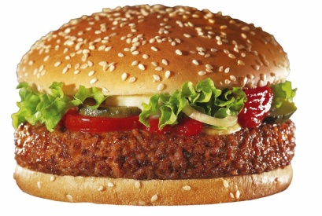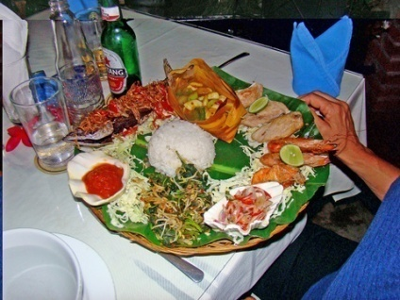
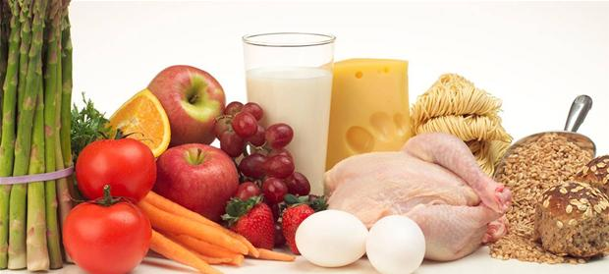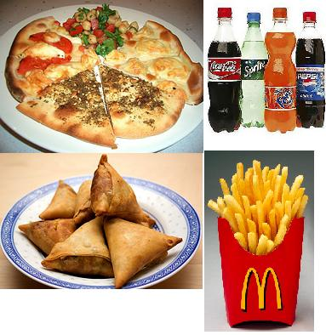
Illit nammineq sunik nerisaqartarnerit allaaseriuk. ( Assilissat qupperneq 5-miittut isumassarsiorfigisinnaavatit.) Makku ilanngussinnaavatit.
- Nerisassat qanoq ittut mamarineruigit?
- Nerisavit peqqinnassusaat eqqarsaatigisarpigit? _____________________________________________________________________________________________________________________________________________________________________________________________________________________________________________________________________________________________________________________________________________________________________________________________________________________________________________________________________________________________________________________________________________________________________________________________________________________________________________________________________________________________________________________________________________________________________________________________________________________________________________________________________________________________________________________________________________________________________________________________________________________________________________________________________________________________________________________________________________________________________________________________________________________________________________________________________________________________________________________________________________________________________________________________________________________________________________________________________________________________________________________________________________________________________________________________________________________________________________________________________________________________________________________________________________________________________________________________________________________________________________________________________________________________________________________________________________________________________________________________________________________________________________________________________________________________________________________________________________________________________________________________________________________________________________________________________________________________________________________________________________________________________________________________________________________________________________________________________________________________________________________________________________________________________________________________________________________________________________________________________________________________________________________________________________________________________________________________________________________________________________________________________________________________________________________________________________________________________________________________________________________________________________________________________________________________________________________________________________________________________________________________________________________________________________________________________________________________________________________________________________
Oqaasilerineq
Suliassaq 4
Oqaasilerisassat ataaniittut suliarikkit

Taggisit
Taggisit ataani allassimasut allanngorarneri allattuiffissamut allattukkit.
Assersuut siulleq allanngorartinneqarpoq
Tassaasoq: ukioq

Taggit taasiinnarniut Taggit taasiinnarniut Taggit allamoorut
ataasersiut qasseersiut ataasersiut
Ukioq | Ukiut | Ukiup
 | Qilalukkat
Eqaluk
 |  | Tuttup
Ammassak
 | Qimmit
 |  | Meeqqap
Aasaq

Kinaassusersiutit
Oqaatsip ataani allassimasup kinaassusersiutai allanngorartillugit allattuiffissamut allattukkit.
:Kammak
Uanga | Uagut
Illit | Ilissi
Uuma | Uku
Nammineq | Namminneq

Oqaluutit
Oqaluutinik annernit arfineq-pingasunik nassaarit ataanullu allattorlugit.
Oqaluutit annerit tassaapput oqaatsit ima ittut:
Anivoq. Oqarpugut. Takuaa Kumippaa.

Ukioq naallugu kalaaliminernik immitsinnut pilersorpugut. Ukiup qanoq ilinera naapertorlugu piniagassat malinnaaffigaavut. Maajimi ammassaat takkukkaangata ammassisarpugut, panertitsillutalu. Juulimi eqaluit takkukkaangata eqalunniartarpugut, tarajorteraluta kiisalu pujoorilluta. Sila nillertikkiartuleraangat aalisakkat sammiunnaarlugit, tuttunut umimmannullu (pisassaqarsimagaangatta) saattarpugut, aamma paarnanik, kimmernanik kigutaarnanillu nuniattaqaagut.

