AEU
Kalaallisut misilitsinneq 2
Sap ak. 48 2010

Ineriartorneq

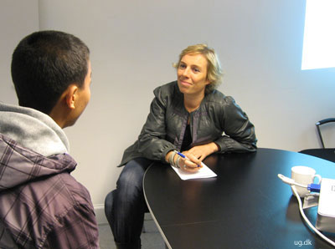

Misilitsinnerup sivisussusaa: Nal. Ak. Pingasut ( 3 timer)
Suliassiissutit tallimaapput: Tamarmik akineqassapput

Sap.ak. misilitsiffik: 48/ 2010
Piffissami nal. 09.00 – 12.00

Atuartup aqqa:______________________________ cpr.nr.__________

Atuarfik:_______________________________________________

Nakkutilliisup atsiornera:______________________________________

Piffissaq tunniussiffik:_______
Ikiuutissat:
Oqaatsit – kalaallisut/qallunaatut & qallunaatut/kalaallisut
Suliassaq 1 Kalaallit Nunatsinni ingerlanerput

Danmark nunatsinnik ilisimasakippallaaqaaq

Qallunaat Nunarput ilisimasaqarfigivallaanngilaat, tusagassiortoq atuakkiortorlu Jan Cortzen Ekstra Bladetimi allappoq. +299 38 39 50 AG
Af redaktionen 12-11 2010 - 05:15
- Kalaallit Nunaata nioqqutissanik eqqussugaasa 95 procentii Danmarkimeersuupput. Qallunaat untritilippassuit kalaallit ingerlatsiviini sulipput. Kalaallit Nunaat isumannaatsuunikkut politikkimi inissisimaneralu pingaaruteqalersimavoq, milliardilikkaanik nalilinnik uuliaqaratarsinnaanera aatsitassaqaratarsinnaaneralu pissutigalugit. Nato-mullu ilaasortaaneq qularnanngitsumik immikkut milliardilikkaanik akeqassagaluarpoq, Kalaallit Nunaanni sakkutooqarfinnik amerikarmiunut atugassaqartitsisimanngitsuugutta.
Taamatut Ekstra Bladetimi ullumi saqqummersumi tusagassiortoq atuakkiortorlu Jan Cortzen allappoq, tassani allaaseralugu nunasiaqarsimasut inuiaat assigiinngitsut qanoq pisarsimaneraat. Assersuutigalugu Belgia, naakkittaatsumik peqqarniitsumillu nunasiani Congo atorsimallugu inuiaqatigiiaallu ilivitsut toqorarlugit.
- Nuna nunasiaateqarsimasoq suli nunasiaatigisimasaminik akisussaassuseqartutut misigisimasutuaq tassaavoq Danmark. Tamanna pivoq inatsisikkut, demokratiskiusumik aalajangiinikkut ukiumut milliardinik arlalinnik Kalaallit Nunaanni Namminersorlutik Oqartussanut atugassaqartitsisarnikkut. Nunasiaateqarsimasut allat ilaannaalluunniit taamaasiunngilaq.
- Danmarki- nunasiaateqarsimasunut allanut sanilliullugu - issittumi nunasiaminik atornerluisimasutut ilerasuuteqartariaqanngilaq.
- Ilisimasat tassaaginnarput ilisimagineqarluartut isummiutiinnakkat naapertuutinngilluinnartut, tassa kalaallit ullaamiit unnummut imiinnartuusut, arnartatik unatartaraat meeqqatillu kaatsillugit. Aatsaat taama ilumuunngitsigisoqarpoq, Jan Cortzen isumaqarpoq.

Ukua aallaavigalugit allaaserinnigit/isummersorit:
- Nunatsinnut nioqqutissanik eqqussuineq
- Qallunaat untritilippassuit kalaallit ingerlatsiviini sulinerat
- Kalaallit Qallunaat Nunaannut atanerput
- Inuiaat kalaallinut isiginnittaaseq
Allaaserinninneq:
________________________________________________________________________________________________________________________________________________________________________________________________________________________________________________________________________________________________ _________________________________________________________________________________________________________________________________________________________________________________________________________________________________________________________________________________________________________________________________________________________________________________________________I______________________________________________________________________________________________________________________________________________________________________________________________________________________________________________________________________________________________________________________________________________________________________________________________ ________________________________________________________________________________________________________________________________________________________________________________________________________________________________________________________________________________________________________________________________________________________________________________________________________________________________________________________________________________________________________________________________________________________________________________________________ ________________________________________________________________________________________________________________________________________________________________________________________________________________________________________________________________________________________________________________________________________________ ________________________________________________________________________________________________________________________________________________________________________________________________________________________________________________________________________________________________________________________________________________

Suliassaq 2 Qinnuteqarneq
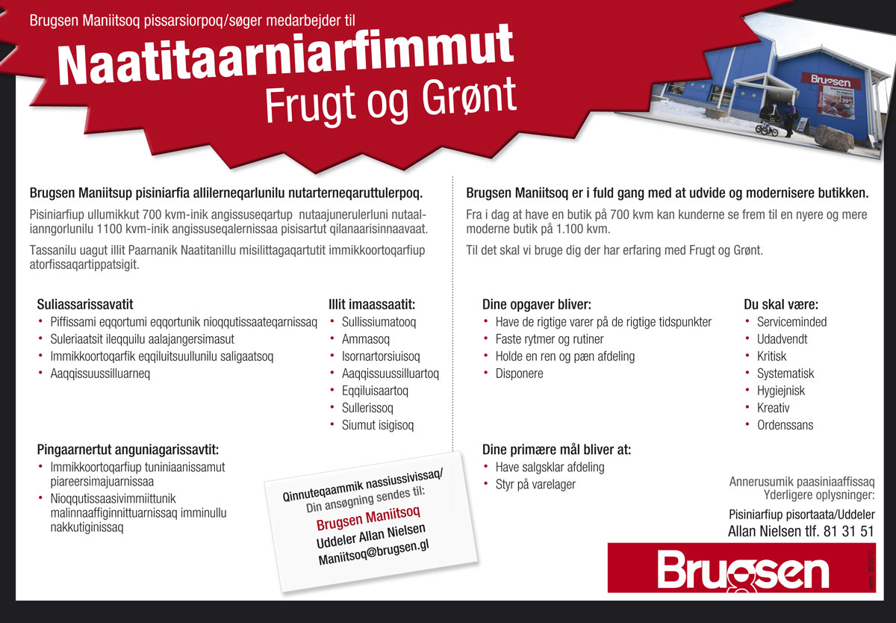
Imminut ilisaritissaatit ”Illit imaassaatit ” aallaavigalugit/tunngavilersorlutillu.
Tassani illit siunissami ilinniartunngortussaanerit aallaavigissavat.
________________________________________________________________________________________________________________________________________________________________________________________________________________________________________________________________________________________________________________________________________________________________________________________________________________________________________________________________________________________________________________________________________________________________________________________________ ________________________________________________________________________________________________________________________________________________________________________________________________________________________________________________________________________________________________________________________________________________________________________________________________________________________________________________________________________________________________________________________________________________________________________________________________________________________________________________________________________________________________________________________________________________________________________________________________________________________________________________________________________________________________________________________________________________________________________________________________________________________________________________________________________________________________________________________________________________

Suliassaq 3 Taallaq
Taallaq atuariarlugu suliassartaa suliarineqassaaq
Silarsuaq takorusupparput
Sumunnalerpit inungaa?
Silarsuatsinnut isigilerpunga
Qimannanga ikiunnga!
Silarsuara qimerluulerpara

Tassaniigit inungaa
Oqartussaaqatiga!
Qimerloorlungu nunarsuaq
Tassani inunngoratta

Silarsuaq takorusupparput
Inuugatta misigissuseqarluta!
Nunarpullu illersorlungu
Inuiaassuseqarfigiuarlungu!

Atuarfimmiit aningaagavit
Tunummut qiviartarputit
Paasisaqartutut ittarputit
Sulissussisussaallutit

Inuujuarusuppungut
Inuit ataqatigalugit!
Atorfissaqarusuppungut!
Nunaqatigiit suleqatigalugit

Tassaniigit inungaa
Oqar…………

Taall./Erinn.: Mads Grønvold

Taallialerineq
Ukua aallaavigalugit:
- Taallap sannaa allaaseriuk
- Taallap imaarisaa, sunaana oqariartuutigigaa
- Taallaq illit kimut piukkuppiuk,- sooq?

________________________________________________________________________________________________________________________________________________________________________________________________________________________________________________________________________________________________________________________________________________________________________________________________________________________________________________________________________________________________________________________________________________________________________________________________ ________________________________________________________________________________________________________________________________________________________________________________________________________________________________________________________________________________________________________________________________________________________________________________________________________________________________________________________________________________________________________________________________________________________________________________________________________________________________________________________________________________________________________________________________________________________________________________________________________________________________________________________________________________________________________________________________________________________________________________________________________________________________________________________________________________________________________________________________________________
________________________________________________________________________________________________________________________________________________________________________________________________________________________________________________________________________________________________________________________________________________________________________________________________________________________________________________________________________________________________________________________________________________________________________________________________________________________________________________________________________________________________________________________________________________________________________________________________________________________________________________________________________________________________________________________________________________________________________________________________
Suliassaq 4 Oqaasilerineq

Ataani oqaaseqatigiit, susulersukkit susalerlugillu

Assersuut: Qimmip qitsuk malersorpaa
Susoq: qimmip susaq:qitsuk

Anaanap maskiina ingutserpaa
____________________________________
Politiit tillinniat malersorpaat
____________________________________
Ilinniartitsisup atuartut oqaluttuuppai
____________________________________
Nakorsaq aggerami meeraq misissorpaa
____________________________________
Anaanama pisuttuarluni taskini katassimavaa
____________________________________
Meeraq pappialamut titartaavoq
____________________________________

Oqaluutit kinaassusersiutilikkit:

Oqaluut: Kinaassusersiutaa:

Nassaarisimavaa -

Iluaqutigaanga -

Allaffeeqqasi -

Angerlarsimaffipput -

Angajoqqaatit -

Atuagaasivitik -

