Piareersarfik
Kalaallisut misilitsinneq AEU 2(Sillimmat / Reserve)
12. august 2011
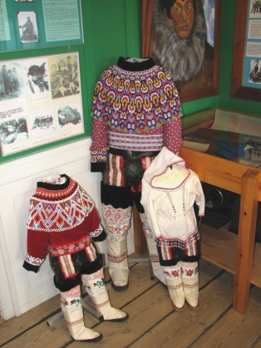

Suliassiissutit arfiniliupput: Tamarmik akineqassapput

Piffissami nal. Ak. 09.00-12.00

Ikiuutissat: Ordbogit: Oqaatsit – kalaallisut/qallunaatut
Misilitsinnerup sivisussusia/ Varighed 3 timer

Atuartup aqqa/ Elevens navn:________________________________________________________________

Cpr.nr.:_________________________________________
Piareersarfik:_______________________________________
Nakkutilliisup atsiornera: Prøvevagtens underskrift:________________________________________________________

Piffissaq tunniussiffik / Tidspunkt for aflevering:______________________________________________________

Kinaassuseq

Suliassaq 1
- Allaaserisaq atuaqqissaaruk

Kalaalimerngit kinaassutsimut takussutissaapput
Nunatta Katersugaasivia kulturikkut eriagisassanut tigussaanngitsunut tunngasunik katersilluni aallartippoq, aallarniutigalugit nerisassiornermut tunngasut kiisalu naasut nakorsaatitut atorneqarnerinut tunngasut
Eriagisassat tigussaanngitsut eqqartussagutsigit sumorujussuaq killissinnaavugut, sorpassuuppummi. Inuiaqatigiit iluanni ileqqut pingaartitallu assigiinngitsut eqqartorneqarsinnaapput, kisiannili aamma inuit ataasiakkaat akornanni, kiisalu sumiiffinni assigiinngitsuni ileqqut allat aamma takussaasarlutik. Aamma pingaaruteqarpoq eqqaamassallugu eriagisassat tigussaanngitsut piffissaq ingerlartillugu, inuillu inuusaasiata allanngorarnera ilutigalugu allanngorartuarmata, taamaammallu katersuinissaq uniinnarnani ingerlajuassalluni, Natuk Lund Olsen, Nunatta Katersugaasiviani katersugaasivilerisoq oqarpoq.
Siornaak Nunatta Katersugaasiviani katersugaasivilerisutut atorfinippoq, immikkut eriagisassat tigussaanngitsut sammissalugit. Siornatigut Nunatta Katersugaasivia eriagisassat tigussaangitsut pillugit immikkut suliniuteqarnikuunngilaq, Natuullu atorfia nutaajuvoq.
Soorunami siornatigut katersugaasivilerisut eriagisassat tigussaanngitsut pillugit toqqaannanngikkaluamik aalluttarsimavaat, maannali uanga taakku toqqaannartumik aallullugit sulilerpunga. Kalaallit Nunaatta massuma tungaatigut siuttutut oqaatigineqarsinnaavoq, qallunaat nunaannimi eriagisassat tigussaanngitsut katersugaasiveqarnermut suli eqqunneqanngillat.

Nerisassat kinaassutsimut attuumapput
Natuk sulilermat aalajangiunneqarpoq nerisassanut, kiisalu naasunut nakorsaatitut atorneqartartunut tunngasut siulliullugit aallunneqassasut.
Maanna suli aallartisarnermiippugut, kisimalu suligama takorloorneqarsinnaavoq piffissaq sivisungaatsiartoq aallartisarnermiissasugut, Natuk oqarpoq.
Nerisassat pillugit paasissutissanik katersilluni aallartikkami, ataatsimut isigalugu oqaluttuarisaanermi periaatsit isummallu (teorier) nerisassanut tunngasut paasiniaaffigivai.
Assersuutigalugu malugissutsit (sanser) pillugit paasiniaavunga. Paasisaralu tassaavoq europamiut isiginnittaasaat malillugu tallimanik malugissuseqartugut. Paaserusunnartut ilagaat kalaallit akornanni malugissutit qanoq inissisimanersut, malugissutsillu suut pingaartinneqarnerunersut. Aamma paasiniakkamma ilagaat inuiaqatigiit iluini nerisat qanoq pingaartinneqartiginersut.
Massakkumut paasisama pingaarnerit ilagaat, kalaalimerngit kinaassutsitsinnut qanoq pingaaruteqartigineri. Qanoq pingaartigineri atiani ersippoq ”Kalaalimerngit” –atia tusaannarlugu takuneqarsinnaavoq uagut kalaallit pingaarteqigigut pinngitsoorsinnaanatigillu – pingaartingaaratsigit allaat immitsinnut atsiussimalluta, Natuk Lund Olsen oqarpoq.

Kalaalimerngit suunerinik paasinninnerit assigiinngillat
Natuup paasiniaanermini sakkutut atugaasa ilagaat atuakkanik atuarneq, kiisalu inunnik attaveqartarneq, taakkulu aqqutigalugit inunnik nunatsinni nerisasserinermik ilisimasaqarluartunik attavissarsiortarneq.
Maannamut paasisama aamma ilagaat, inuit suut kalaaliminiunerannik paasinnittaasiisa assigiinnginneri. Ilai isumaqarput nerisassat naqqaniit nammineq sanaat, assersuutigalugu uumasut nammineq pisareriarlugit panertillugit nerisassiat kisimik kalaaliminernik taasariaqartut, ilaalli isumaqarput nerisassiat nunatsinneersut, allamiut nerisassaannik akullugit nerisassiat aamma kalaaliminernik taaneqarsinnaasut, Natuk oqarpoq.
Aamma eqqarsaatersuutigisimavaa taaguut ”kalaalimerngit” qanga, sumillu aallaveqarluni pinngorsimanersoq. Eqqoriaavorlu kristumiuussuseq nunatsinnut eqqunneqarmat pinngorsimassasoq, ”allamiut” takkummata suut nammineq piginerlugit naqissusiinertut.
---

Atuagassiamit ”Sila”-mit tigulaagaq. Ukiaq 2010 Qup.16. Allaaserinnittoq. Aminnguaq Dahl Petrussen

Suliassaq 2
- Allaaserinnigit.

Makku ilanngussinnaavatit
- Eriagisat tigussaanngitsut suusinnaanerat
- Suut kalaaliminernik taaneqartarnerat
- Kalaalimernit kinaassutsimut tunngatinneqarnerat
- Kalaallit Nunaata nunanut allanut sanilliullugu eriagisassat tungaatigut inissisimanera.
___________________________________________________________________________________________________________________________________________________________________________________________________________________________________________________________________________________________________________________________________________________________________________________________________________________________________________________________________________________________________________________________________________________________________________________________________________________________________________________________________________________________________________________________________________________________________________________________________________________________________________________________________________________________________________________________________________________________________________________________________________________________________________________________________________________________________________________________________________________________________________________________________________________________________________________________________________________________________________________________________________________________________________________________________________________________________________________________________________________________________________________________________________________________________________________________________________________________________________________________________________________________________________________________________________________________________________________________________________________________________________________________________________________________________________________________________________________________________________________________________________________________________________________________________________________________________________________________________________________________________________________________________________________________________________________________________________________________________________________________________________________________________________________________________________________________________________________________________________________________________________________________________________________________________________________________________________________________________________________________________________________________________________________________________________________________________________________________________________________________________________________________________________________________________________________________________________________________________________________________________________________________________________________________________________________________________________________________________________________________________________________________________________________________________________________________________________________________________________________________

Suliassaq 3

Kalaallisuut kinaassutsimut tunngatinneqartarput.

Asseq 1
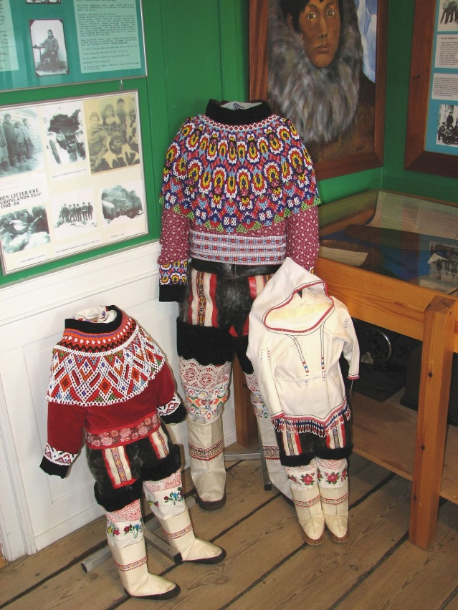
http://lh5.ggpht.com/_ZyD2clND16w/R2_CPA6JhBI/AAAAAAAABhQ/JJioVQEf8Uk/Gr%C3%B8nland%20%20178.jpg

Asseq 2
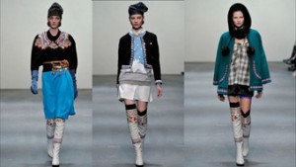
http://ibenmondrup.dk/wp-content/uploads/Kalaallisuut_22812l-300x169.jpg

Suliassaq 4
- Isummersorit uku tunngavigalugit.

Makku ilanngussinnaavatit
- Kalaallisuut qanoq isumaqartinneqarnerat
- Kinaassutsimut qanoq pingaaruteqartiginerat
- Asseq 2-mi nunami allamiut kamiliaat isummerfigikkit
- Suut allat kinaassutsimut tunngassuteqarsinnaanerat
________________________________________________________________________________________________________________________________________________________________________________________________________________________________________________________________________________________________________________________________________________________________________________________________________________________________________________________________________________________________________________________________________________________________________________________________________________________________________________________________________________________________________________________________________________________________________________________________________________________________________________________________________________________________________________________________________________________________________________________________________________________________________________________________________________________________________________________________________________________________________________________________________________________________________________________________________________________________________________________________________________________________________________________________________________________________________________________________________________________________________________________________________________________________________________________________________________________________________________________________________________________________________________________________________________________________________________________________________________________________________________________________________________________________________________________________________________________________________________________________________________________________________________________________________________________________________________________________________________________________________________________________________________________________________________________________________________________________________________________________________________________________________________________________________________________________________________________________________________________________________________________________________________________________________________________________________________________________________________________________________________________________________________________________________________________________________________________________________________________________________________________________________________________________________________________________________________________________________________________________________________________________________________________________________________________________________________________________________________________________________________________________________________________________________________________

Suliassaq 5

Oqaasilerineq

Oqaasilerineq-oqaluutit taggisillu

Oqaaseqatigiit ataaniittut taggisinut oqaluutinullu immikkoortitikkit.
Assersuut:
- Illup qaliani qupaloraarsuk mitsimavoq
Taggisit Oqaluutit
Illup mitsimavoq
qaliani
qupaloraarsuk

- Panitta errugassat errorlugit naammassivai.
Taggisit Oqaluutit
______________________ _______________________
______________________ _______________________

- Ippernat aasap ilisarnaatigai.
Taggisit Oqaluutit
______________________ _______________________
______________________

- Aasami feeriarnissaq qilanaarnarsivoq.
Taggisit Oqaluutit
______________________ _______________________
______________________

- Seqineq qullariivilluni nuivoq.
Taggisit Oqaluutit
______________________ _______________________
_______________________

Suliassaq 6

Oqaluutit kinaassusersiutaat
Oqaluut Kinaassusersiutaa

Assersuut
Tuaviorpoq: (Una)
Tuaviuuppaa: (Uuma-una)
- Takuaa:____________________________________
- Eqqarsarpoq:________________________________
- Oqarami:___________________________________
- Nerigamiuk:_________________________________
- Suaarpaa:___________________________________
- Tipigippoq:__________________________________

