AEU 2

Modultest dansk
Sygeeksamen august 2012

1 del

Skriftlig fremstilling: forståelse og formulering
Samtalerunde i grupper kl. 9.00 til 9.30
Individuel besvarelse kl. 9.45 til 12.00

Elevens navn__________________________ CPR. nr.:_____________________________

Skolens navn _______________________________________________________________

Prøvevagtens navn ________________Tidspunkt for aflevering __________________

Hjælpemidler: følgende hjælpemidler må benyttes :
Ordbøger: Nudansk ordbog eller Retskrivnings - og betydningsordbog
grønlandsk / dansk
dansk/grønlandsk

Indhold:

Opgavesættet består af 2 opgaver:

Begge opgaver skal besvares!

Suliassat tamarmik akineqassapput!

1. Beskrivelse af to billeder …………………………………………………….........................side 3

2. Fri formulering: Digt en historie! ....................................................................side 6

Opgave 1: Beskriv hvad du ser på de to billeder:
Assilissani marluusuni takusatit oqaluttuarikkit
Billede 1
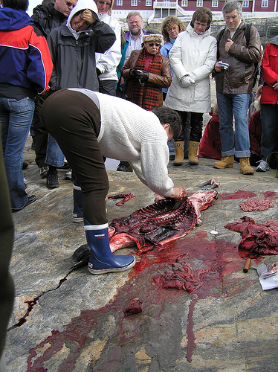

Billede 2
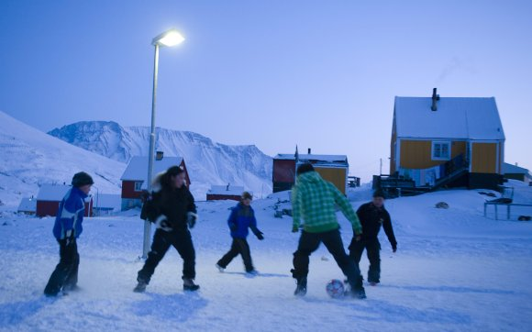

______________________________________________________________________________________________________________________________________________________________________________________________________________________________________________________________________________________________________________________________________________________________________________________________________________________________________________________________________________________________________________________________________________________________________________________________________________________________________________________________________________________________________________________________________________________________________________________________________________________________________________________________________________________________________________________________________________________________________________________________________________________________________________________________________________________________________________________________________________________________________________________________________________________________________________________________________________________________________________________________________________________________________________________________________________________________________________________________________________________________________________________________________________________________________________________________________________________________________________________________________________________________________________________________________________________________________________________________________________________________________________________________________________________________________________________________________________________________________________________________________________________________________________________________________________________________________________________________________________________________________________________________________________________________________________________________________________________________________________________________________________________________________________________________________________________________________________________________________________________________________________________________________________________________________________________________________________________________________________________________________________________________________________________________________________________________________________________________________________________________________________________________________________________________________________________________________________________________________________________________________________________________________________________________________________________________________________________________________________________________________________________________________________________________________________________________________________________________________________________________________________________________________________________________________________
Opgave 2. Fri formulering: digt en historie

Vælg et af billederne og digt en historie om personerne: Hvem er de? Hvad laver de? Hvad tænker de på?
Assilissat arlaat toqqaruk inuttaasullu aallaavigalugit oqaluttualiorlutit: Kikkuuppat? Sulerippat? Qanoq eqqarsarpat
__________________________________________________________________________________________________________________________________________________________________________________________________________________________________________________________________________________________________________________________________________________________________________________________________________________________________________________________________________________________________________________________________________________________________________________________________________________________________________________________________________________________________________________________________________________________________________________________________________________________________________________________________________________________________________________________________________________________________________________________________________________________________________________________________________________________________________________________________________________________________________________________________________________________________________________________________________________________________________________________________________________________________________________________________________________________________________________
__________________________________________________________________________________________________________________________________________________________________________________________________________________________________________________________________________________________________________________________________________________________________________________________________________________________________________________________________________________________________________________________________________________________________________________________________________________________________________________________________________________________________________________________________________________________________________________________________________________________________________________________________________________________________________________________________________________________________________________________________________________________________________________________________________________________________________________________________________________________________________________________________________________________________________________________________________________________________________________________________________________________________________________________________________________________________________________
__________________________________________________________________________________________________________________________________________________________________________________________________________________________________________________________________________________________________________________________________________________________________________________________________________________________________________________________________________________________________________________________________________________________________________________________________________________________________________________________________________________________________________________________________________________________________________________________________________________________________________________________________________________________________________________________________________________________________________________________________________________________________________________________________________________________________________________________________________________________________________________________________________________________________________________________________________________________________________________________________________________________________________________________________________________________________________________
______________________________________________________________________________________________________________________________________________________________________________________________________________________________________________________________________________________________________________________________________________________________________________________________________________________________________________________________________________________________________________________________________________________________________________________________

