Piareersarfik
Kalaallisut misilitsinneq AEU 1 (Atuuttussaq / Ordinær)

25. maj 2012
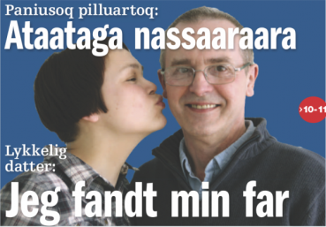
Suliassiissutit sisamaapput: Tamarmik akineqassapput
Ulloq misilitsiffik: 25. maj 201
Piffissami nal. Ak. 9.00 - 9.30 – samtalerunde - Oqaloqatigiinneq
9.45 - 12.00 - Individuel skriftlig besvarelse - Kisimiilluni allaaserinninneq

Ikiuutissat: Ordbogit: Oqaatsit – kalaallisut/qallunaatut
Misilitsinnerup ataatsimut sivisussusia/ Varighed 3 timer
Atuartup aqqa/ Elevens navn:________________________________________________________________
Cpr.nr.:_________________________________________
Piareersarfik:_______________________________________

Nakkutilliisup atsiornera: Prøvevagtensunderskrift:________________________________________________________
Piffissaq tunniussiffik / Tidspunkt for aflevering:______________________________________________________
Suliassaq 1
Allaaserisaq atuaqqissaaruk

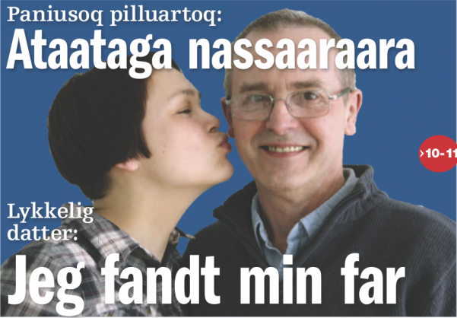
”Ataataga nassaarivara”
Ukiorpassuarni paniusup ataatavimminik ujaasinera poorskikkunni naapeqqinnermik kinguneqarpoq
Susanne Egede Bourup arfineq-marluinnarnik qaammateqarluni Aasianni ajamini meerarsiaalerpoq. Tamanna aaqqiigallarneruvoq arnaata Nuummeersup inissarsinissaata tungaanut. Tamannali pinngisaannarpoq. 1981-imi pisimavoq. Ajaata nammineerluni pingasunik meeraqareersup nammineq panimmisut pivaa.
- Pitsaasumik peroriartorpunga. Meeraaninni asaneqarluarlungalu isumagineqarpunga. Ullumikkut angajoqqaarsiakka angajoqqaavittut isigaakka. Susanne Egede Bourup oqarpoq.
Nuummi illoqarfiup ilaani Qernertunnguani inissiamini issiavoq. Akinnguaniippoq ataatavia Peter panini takuniarlugu Canadamiit aggersimasoq. Aatsaat siullermeerluni Kalaallit Nunaanniippoq 1983-miilli.

Meerarsiaq
- Angajoqqaarsiakka kalaaliviupput meerarsiaallungalu ilisimajuaannarsimavara - isertuussaanngilaq. Oqartuartarput: “Anaanat ajagivat ajallu anaanaralugu”
Annivinili ilisarilinngisaannarpaa. Susanne arfineq-pingasunik ukioqartoq toquvoq.
- Taamanikkut uinilu Danmarkimi najugaqarpoq, uangalu Aasianni najugaqarlunga. Nalunngilarami sumiikkaluarnersumik ataataveqarlunga, eqqarsaatiginerli ajorpara. Susanne oqaluttuarpoq.
- Ikinngutima aperiuartarpaannga kina ataatavigineriga nassaarerusunnginnerigalu. Apeqquteqartarnerannik alapernaasilerpunga. Aalajangerpungalu nammineq misissorniarlugu, Susanne oqaluttuarpoq. Taamanikkulli ataatavimi aqqa naluaa.

Iluatsinngilaa
- Isumaqartuartarsimavunga Peter Jensenimik ateqartoq Skjødtiunngitsumilli. Politiit oqaluffilluunniit angummik taama atilimmik paasissutissaateqanngillat. Danmarkimilu Peter Jensenimik atillit amerlaqaat.
Paasisaqanngilarli eqqartuussivimmullu saaffiginnikkaluarnera kinguneqanngilaq. Aalajangerpoq Danmarkimi tv-kkut aallakaatitassiamut “Sporløsimut” saaffiginninniarluni.
- Peter Jensenimik anaanannullu paasissutissanik tunivakka. Oqarfigineqarpungalu ukiup affaani tullermi ujaaseqqissanngitsunga paasiniaaneq ingerlanniarpassuk kisianni tusarfigeqqinngisaannarpakka. Susanne oqaluttuarpoq.
Inatsisitigut ikiuisarfik nutaaq IKIU atulerpoq tassanilu innersuunneqarluni kommunimi isumaginnittoqarfimmi allagaatinik takunninnissaminut qinnuteqaqqullugu.
- Ataatama ativia aatsaat tassani paasivara 2008-mi. Oqiliallaqaanga misigisimavungali ingerlariaqqinnissannut suli piareersimananga.

Aqqa paasivaa
Ukiup aappaata affaa qaangiummat aatsaat ujaasinini aallarteqqippaa. Naalagaaffiup sinniisoqarfianut saaffiginninnerup kinguneraa ataatavini pillugu paasissutissanik pissarsinera. Tassanngaannaq najugaa oqarasuaataatalu normua pigilerpaa. Tassalu oktobarimi 2011-mi
Vejlemi oqarasuaatip normua toortaramiuk uummataa tilleruluppoq. Niviarsiaraq akerpallattoq kingorna illooraralugu paasivaa. Danmarkimi ilaquttat nuannaartut angutaanut Petermut sianipallapput taamanikkullu Vancouverimit najugaqartumut.

Oqarasuaat attaveqanngilaq
Angutaa Peter panimmi oqaluttuaanik tusarnaartoq nangippoq.
- Taamanikkut Vancouverip eqqaani sisorariartarfimmiippunga oqarasuaatikkut attaveqanngitsumi. Danmark Vancouverilu akunnernik qulingiluanik nikingapput, unnukkullu angerlarama Danmarkimi unnuaavoq, ilaqutariillu attaveqarnissaat ajornakusoorluni.
Unnuk taanna suliffimminit angerlarami qatanngutiminit e-mailisisimavoq, allassimalluni piaarnerpaamik angerlamut sianissasoq.
- Ajorluinnartumik pisoqarsimanissaa naatsorsuutigaara. Nukkannut sianipallappunga paasillugulu Susanne sianersimasoq. Oqarasuaatip normua pivara erngerlungalu sianerlunga.
Unitsiarpoq killitsinnermini qullililaarluni:
- Aallaqqaammut aperaaq ”Qanga inunngorsimavit” uppernarserusuppaami inuk eqqortoq oqaloqatigalugu, illarluni oqaluttuarpoq.
Tigulaariffik Louise M. Kleemann. Atuagagdliutit pingasunngorneq Aprilip 18-at 2012

”Ataataga nassaarivara”
Suliassaq 2
- Allaaserisamit apeqqutit akikkit
- Susannemuna ataatani qanoq ililluni ujarsimagaluaraa?
________________________________________________________________________________________________________________________________________________________________________________________________________________________________________________________________________________________________________________________________

- Susannep meeraanera qanoq issimava?
________________________________________________________________________________________________________________________________________________________________________________________________________________________________________________________________________________________________________________________________

- Susanne kikkunni meerarsiaasimava?
________________________________________________________________________________________________________________________________________________________________________________________________________________________________________________________________________________________________________________________________

- Ataatavimmi atia qanoq ililluni pissarsiarisimavaa?
________________________________________________________________________________________________________________________________________________________________________________________________________________________________________________________________________________________________________________________________
- Ataatavini nanigamiuk sumiittoq nanivaa?
________________________________________________________________________________________________________________________________________________________________________________________________________________________________________________________________________________________________________________________________

- Naapippat? Naapinnerat qanoq kinguneqarpa?
________________________________________________________________________________________________________________________________________________________________________________________________________________________________________________________________________________________________________________________________

Suliassaq 3
- Atuariikkat isummerfigiuk uku aallaavigisinnaavatit
- Nagguinnik anaanavimmik ataavimmillu ilisimasaqarnissaq qanoq inunnut pingaaruteqartigisinnaava?
- Ataatap paniullu naapikkamik misigisimasaat qanoq igaajuk?
________________________________________________________________________________________________________________________________________________________________________________________________________________________________________________________________________________________________________________________________________________________________________________________________________________________________________________________________________________________________________________________________________________________________________________________________________________________________________________________________________________________________________________________________________________________________________________________________________________________________________________________________________________________________________________________________________________________________________________________________________________________________________________________________________________________________________________________________________________________________________________________________________________________________________________________________________________________________________________________________________________________________________________________________________________________________________________________________________________________________________________________________________________________________________________________________________________________________________________________________________________________________________________________________________________________________________________________________________________________________________________________________________________________________________________________________________________________________________________________________________________________________________________________________________________________________________________________________________________________________________________________________________________________________________________________________________________________________________________________________________________________________________________________________________________________________________________________________________________________________________________________________________________________________________________________________________________________________________________________________________________________________________________________________________________________________________________________________________________________________________________________________________________________________________________________________________________________________________________________________________________________________________________________________________________________________________________________________________________________________________________________________________________________________________________________________________________________________________________________________________________________________________________________________________________________________________________________________________________________________________________________________________________________________________________________________________________________________________________________________________________________________________________________________________________________________________________________________________________________________________________________________________________________________________________________________________________________________________________________________________________________________________________________________________________________________________________________________________________________________________________________________________________________________________________________________________________________________________________________________________________________________________________________________________________________________________________________________________________________________________________________________________________________________________________

Suliassaq 4
Ilanngutassiaq atuaruk
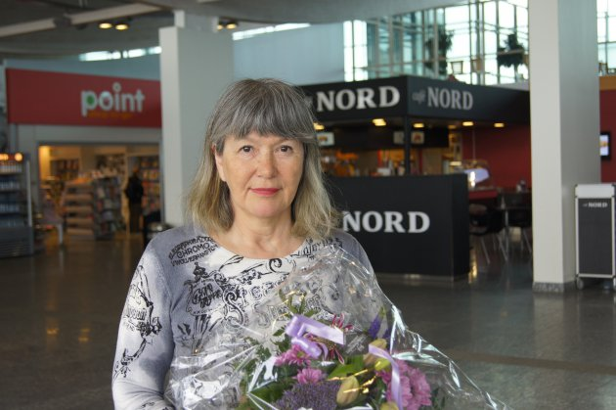

Ilumiu 119.000 koruuninik aningaasaliiffigineqartoq
Ilumiu, ernisussiortumit Esther Hammekenimit 2008-mi pilersinneqartoq ippassaq arfininngornermi Danmarkimi Odd Fellow Ordenenimit 119.000 koruuninik aningaasaliiffigineqarpoq
Af Rimdahl Th. Høegh
15:34, 29. April 2012
Ernisussiortoq Esther Hammeken, kalaallinut inuusuttunut naartusunut anaananngortussanut ilaqutariinngortussanullu ulluunerani højskolimik Ilumiumik aallarniisoq, ippassaq Danmarkimi Odd Fellow Ordenenimit 119.000 koruuninik aningaasaliiffigineqarpoq.
2008-miilli kalaallit inuusuttut naartusut 16-it Ilumiup aaqqissuussaanut ilaasimapput. Taakku ilaat 14-it maanna ilinniagaqarput, ataaserlu isumaginninnermi ikiortitut naammassisimalluni.
Pineqartup iluani suliniuterpassuarnut sanilliulluni Ilumiu peqataasut ataasiakkaat pisariaqartitaannik aallaaveqartarpoq pikkorissarnermillu ataasiakkaat pisariaqartitaat aallaavigalugit aaqqissuussisarluni.
Odd Fellow Ordenenip Aalborgimi tapiissutinik agguaaneranut nakorsaqarnikkut ilisimatusartut, atuakkiortut, nipilersortartut, ikiuiniaqatigiiffiit meeqqanullu suliniaqatigiiffiit suliniutiminnut aningaasanik qinnuteqarsimapput. Ilumiu Esther Hammekenilu qinnuteqartut akornanni aningaasanik amerlanerpaanik tunissuteqarfigineqarput.
Peqatigiiffik kalaallit meerartaat, Foreningen Grønlandske Børn, 45.000 koruuninik tunissuteqarfigineqarpoq, taakkuninngalu Jyllandip Avannaani immikkoortortamut aqutsisoq Stine Nikolajsen tigusisuuvoq.
Esther Hammeken oqaluttuarpoq, arfininngornermi tapiissutinik agguaasoqarnera persuarsiorfiusorujussuarmik naleqquttunik atisalersorfiusumik ingerlanneqartoq. Tunissutinullu qujassuteqartussanngorami ima pissangatigalunilu killitsissimatigaaq qujassuteqarluni oqalugiaatissami allanneqareersimasup ilaani immikkuualuttut puigungajassimagini, kisiannili iluatsittoq.
Aallerfik: http://sermitsiaq.ag/kl/node/124858
Suliassaq 4
  - Ilumiup suliniutai qanoq isumaqarfigaagit?
  - Suliniaqatigiiffik pioreersoq imaluunniit pilersinneqartariaqartoq sorleq, ilinnut qanoq iluaqutaasinnaanera pillugu allaaserinnigit.
________________________________________________________________________________________________________________________________________________________________________________________________________________________________________________________________________________________________________________________________________________________________________________________________________________________________________________________________________________________________________________________________________________________________________________________________________________________________________________________________________________________________________________________________________________________________________________________________________________________________________________________________________________________________________________________________________________________________________________________________________________________________________________________________________________________________________________________________________________________________________________________________________________________________________________________________________________________________________________________________________________________________________________________________________________________________________________________________________________________________________________________________________________________________________________________________________________________________________________________________________________________________________________________________________________________________________________________________________________________________________________________________________________________________________________________________________________________________________________________________________________________________________________________________________________________________________________________________________________________________________________________________________________________________________________________________________________________________________________________________________________________________________________________________________________________________________________________________________________________________________________________________________________________________________________________________________________________________________________________________________________________________________________________________________________________________________________________________________________________________________________________________________________________________________________________________________________________________________________________________________________________________________________________________________________________________________________________________________________________________________________________________________________________________________________________________________________________________________________________________________________________________________________________________________________________________________________________________________________________________________________________________________________________________________________________________________________________________________________________________________________________________________________________________________________________________________________________________________________________________________________________________________________________________________________________________________________________________________________________________________________________________________________________________________________________________________________________________________________________________________________________________________________________________________________________________________________________________________________________________________________________________________________________________________________

