AEU 2

Modultest dansk

December 2013

1 del

Skriftlig fremstilling: forståelse og formulering

Samtalerunde i grupper kl. 9.00 til 9.30

Individuel besvarelse kl. 9.45 til 12.00

Elevens navn__________________________ CPR. nr.:_____________________________

Skolens navn ___________________________________________________________________________

Prøvevagtens navn ________________Tidspunkt for aflevering _______________________

Hjælpemidler: følgende hjælpemidler må benyttes:

Ordbøger:

Nudansk ordbog, Retskrivnings - og betydningsordbog
Grønlandsk / dansk
Dansk/grønlandsk

Indhold:

Opgavesættet består af 2 opgaver:

Begge opgaver skal besvares!

Suliassat tamarmik akineqassapput!

1. Beskrivelse af 3 billeder ………………………………………………..……side 3

2. Fri formulering: Skriv om grønlandske traditioner……….................................side 8

Opgave 1: beskrivelse af 3 billeder:

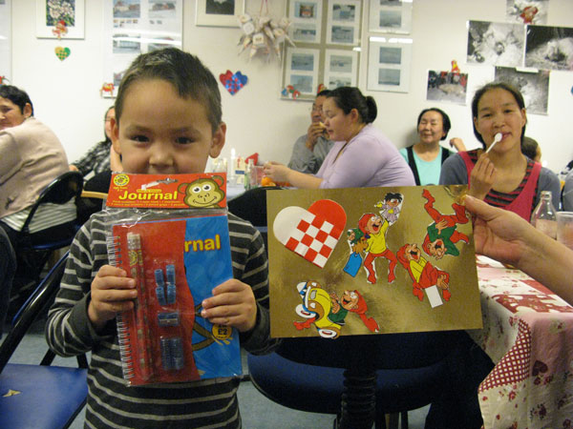

Beskrivelse af billede 1
Asseq 1-ip allaaserinera

________________________________________________________________________________________________________________________________________________________________________________________________________________________________________________________________________________________________________________________________________________________________________________________________________________________________________________________________________________________________________________________________________________________________________________________________________________________________________________________________________________________________________________________________________________________________________________________________________________________________________________________________________________________________________________________________________________________________________________________________________________________________________________________________________________________________________________________________________________________________________________________________________________________________________________________________________________________________________________________________________________________________________________________________________________________________________________________________________________________________________________________________________________________________________________________________________________________________________________________________________________________________________________________________________________________________________________________________________________________________________________________________________________________________________________________________________________________________________________________________________________________________________________________________________________________________________________________________________________________________________________________________________________________________________________

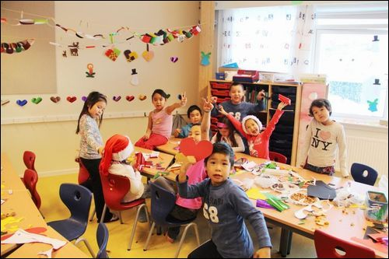
Billede 2

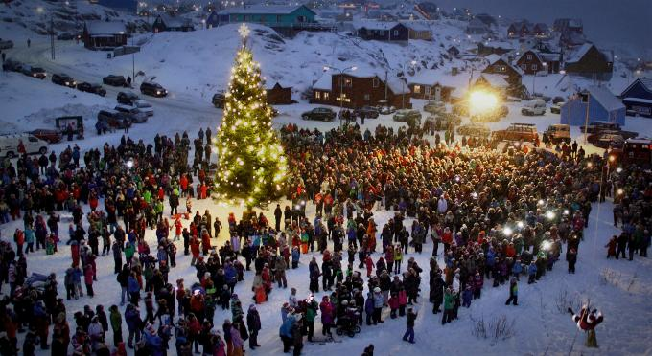
Billede 3
Beskriv hvad du ser på billede 2 og 3
Assini 2-mi aamma 3-mi takusatit aallaaserikkit ________________________________________________________________________________________________________________________________________________________________________________________________________________________________________________________________________________________________________________________________________________________________________________________________________________________________________________________________________________________________________________________________________________________________________________________________________________________________________________________________________________________________________________________________________________________________________________________________________________________________________________________________________________________________________________________________________________________________________________________________________________________________________________________________________________________________________________________________________________________________________________________________________________________________________________________________________________________________________________________________________________________________________________________________________________________________________________________________________________________________________________________________________________________________________________________________________________________________________________________________________________________________________________________________________________________________________________________________________________________________________________________________________________________________________________________________________________________________________________________________________________________________________________________________________________________________________________________________________________________________________________________________________________________________________________________________________________________________________________________________________________________________________________________________________________________________________________________________________________________________________________________________________________________________________________________________________________________________________________________________________________________________________________________________________________________________________________________________________________________________________________________________________________________________________________________________________________________________________________________________________________________________________________________________________________________________________________________________________________________________________________________________________________________________________________________________________________________________________________________________________________________________________________________________________________________________________________________________________________________________

Opgave 2. Fri formulering:

Skriv om nogle af de traditioner i Grønland, som du godt kan lide !

Kalaallit Nunaanni ileqqulersortarneq aammalu ileqqunik pigiliussisimasanik, illit nuannarisannik allaaserinnigit.

________________________________________________________________________________________________________________________________________________________________________________________________________________________________________________________________________________________________________________________________________________________________________________________________________________________________________________________________________________________________________________________________________________________________________________________________________________________________________________________________________________________________________________________________________________________________________________________________________________________________________________________________________________________________________________________________________________________________________________________________________________________________________________________________________________________________________________________________________________________________________________________________________________________________________________________________________________________________________________________________________________________________________________________________________________________________________________________________________________________________________________________________________________________________________________________________________________________________________________________________________________________________________________________________________________________________________________________________________________________________________________________________________________________________________________________________________________________________________________________________________________________________________________________________________________________________________________________________________________________________________________________________________________________________________________________________________________________________________________________________________________________________________________________________________________________________________________________________________________________________________________________________________________________________________________________________________________________________________________________________________________________________________________________________________________________________________________________________________________________________________________________________________________________________________________________________________________________________________________________________________________________________________________________________________________________________________________________________________________________________________________________________________________________________________________________________________________________________________________________________________________________________________________________________________________________________________________________________________________________________

