AEU 2

Modultest dansk

2. april 2013

1 del

Skriftlig fremstilling: forståelse og formulering

Samtalerunde i grupper kl. 9.00 til 9.30

Individuel besvarelse kl. 9.45 til 12.00

Elevens navn__________________________ CPR. nr.:_____________________________

Skolens navn ___________________________________________________________________________

Prøvevagtens navn ________________Tidspunkt for aflevering _______________________

Hjælpemidler: følgende hjælpemidler må benyttes:

Ordbøger:

Nudansk ordbog, Retskrivnings - og betydningsordbog
Grønlandsk / dansk
Dansk/grønlandsk

Indhold:

Opgavesættet består af 2 opgaver:

Begge opgaver skal besvares!

Suliassat tamarmik akineqassapput!

1. Beskrivelse af 3 billeder ………………………………………………..……side 3

2. Fri formulering: Skriv om en dejlig oplevelse i dit liv....................................side 8

Opgave 1: beskrivelse af 3 billeder:

Beskriv hvad du ser på de tre billeder:

Assilissani pingasuusuni takusatit allaaserikkit

Billede1:

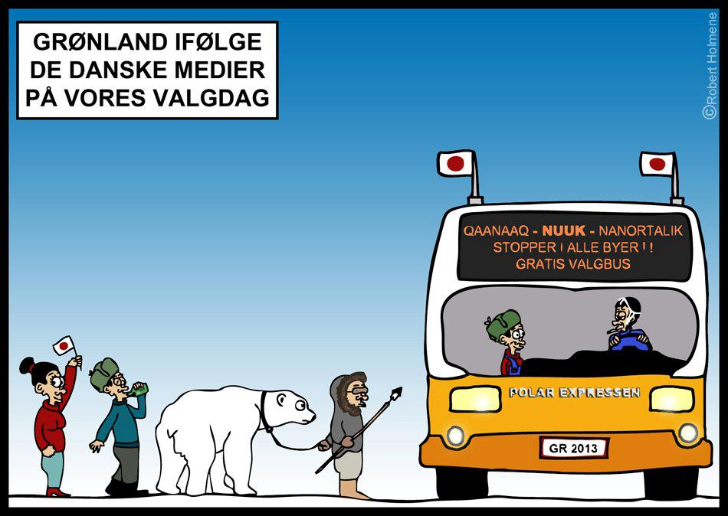
Robert Holmene

Tegningen er lavet af Robert Holmene i anledning af de danske mediers dækning af det grønlandske valg.
Den danske avis, Politiken bragte en artikel med overskriften. "Busser kører over hele Grønland, da valgstederne kun ligger i Nuuk", TV2 havde det japanske flag på i over 30 sekunder - og DR1 vender det grønlandske flag på hovedet.

Kalaallit Nunaanni qinersinermut atatillugu Robert Holmene qallunaat tusagassiutaannit titartaasimavoq.
Qallunaat aviisianni Politikenimi allaatigineqartut ilaanni qulequtarineqarpoq: ”Kalaallit Nunaat tamakkerlugu bussit Nuup tungaanut ilaaffigineqarsinnaapput, Nuuk kisimi qinersi-veqarmat”, TV2-mi sekundit 30-t sinnerlugit japanimiut erfalasuat atorneqarsimavoq – DR1-imilu Kalaallit Nunaata erfalasua killormut saatillgu ikkunneqarsimalluni.

Beskrivelse af billede 1

________________________________________________________________________________________________________________________________________________________________________________________________________________________________________________________________________________________________________________________________________________________________________________________________________________________________________________________________________________________________________________________________________________________________________________________________________________________________________________________________________________________________________________________________________________________________________________________________________________________________________________________________________________________________________________________________________________________________________________________________________________________________________________________________________________________________________________________________________________________________________________________________________________________________________________________________________________________________________________________________________________________________________________________________________________________________________________________________________________________________________________________________________________________________________________________________________________________________________________________________________________________________________________________________________________________________________________________________________________________________________________________________________________________________________________________________________________________________________________________________________________________________________________________________________________________________________________________________________________________________________________________________________________________________________________

Billede 2

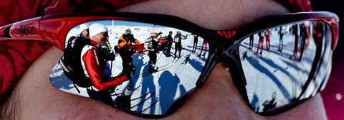

Billede 3

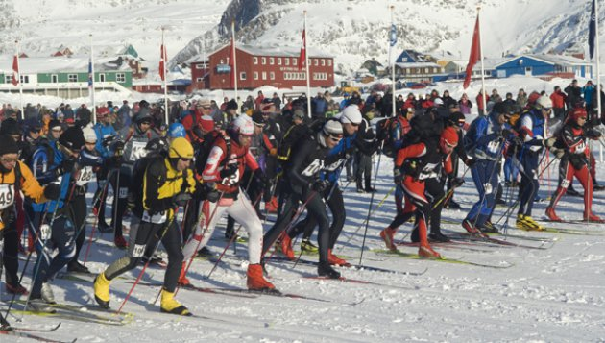

Beskriv hvad du ser på billede 2 og 3 ________________________________________________________________________________________________________________________________________________________________________________________________________________________________________________________________________________________________________________________________________________________________________________________________________________________________________________________________________________________________________________________________________________________________________________________________________________________________________________________________________________________________________________________________________________________________________________________________________________________________________________________________________________________________________________________________________________________________________________________________________________________________________________________________________________________________________________________________________________________________________________________________________________________________________________________________________________________________________________________________________________________________________________________________________________________________________________________________________________________________________________________________________________________________________________________________________________________________________________________________________________________________________________________________________________________________________________________________________________________________________________________________________________________________________________________________________________________________________________________________________________________________________________________________________________________________________________________________________________________________________________________________________________________________________________________________________________________________________________________________________________________________________________________________________________________________________________________________________________________________________________________________________________________________________________________________________________________________________________________________________________________________________________________________________________________________________________________________________________________________________________________________________________________________________________________________________________________________________________________________________________________________________________________________________________________________________________________________________________________________________________________________________________________________________________________________________________________________________________________________________________________________________________________________________________________________________________________________________________________________

Opgave 2. Fri formulering:

Skriv om en dejlig oplevelse i dit liv.

Grønlandsk oversættelse
Inuuninni misigisimasat nuannernerpaaq pillugu allaaserinnigit.

________________________________________________________________________________________________________________________________________________________________________________________________________________________________________________________________________________________________________________________________________________________________________________________________________________________________________________________________________________________________________________________________________________________________________________________________________________________________________________________________________________________________________________________________________________________________________________________________________________________________________________________________________________________________________________________________________________________________________________________________________________________________________________________________________________________________________________________________________________________________________________________________________________________________________________________________________________________________________________________________________________________________________________________________________________________________________________________________________________________________________________________________________________________________________________________________________________________________________________________________________________________________________________________________________________________________________________________________________________________________________________________________________________________________________________________________________________________________________________________________________________________________________________________________________________________________________________________________________________________________________________________________________________________________________________________________________________________________________________________________________________________________________________________________________________________________________________________________________________________________________________________________________________________________________________________________________________________________________________________________________________________________________________________________________________________________________________________________________________________________________________________________________________________________________________________________________________________________________________________________________________________________________________________________________________________________________________________________________________________________________________________________________________________________________________________________________________________________________________________________________________________________________________________________________________________________________________________________________________________________

