AEU 2

Modultest dansk

21 maj 2013

1 del

Skriftlig fremstilling: forståelse og formulering

Samtalerunde i grupper kl. 9.00 til 9.30

Individuel besvarelse kl. 9.45 til 12.00

Elevens navn__________________________ CPR. nr.:_____________________________

Skolens navn ___________________________________________________________________________

Prøvevagtens navn ________________Tidspunkt for aflevering _______________________

Hjælpemidler: følgende hjælpemidler må benyttes:

Ordbøger:

Nudansk ordbog, Retskrivnings - og betydningsordbog
Grønlandsk / dansk
Dansk/grønlandsk

Indhold:

Opgavesættet består af 2 opgaver:

Begge opgaver skal besvares!

Suliassat tamarmik akineqassapput!

1. Beskrivelse af 3 billeder ………………………………………………..……side 3

2. Fri formulering: Skriv om dine fremtidsdrømme………..................................side 8

Opgave 1: beskrivelse af 3 billeder:

Beskriv hvad du ser på de tre billeder:

Assilissani pingasuusuni takusatit allaaserikkit:

Billede1:
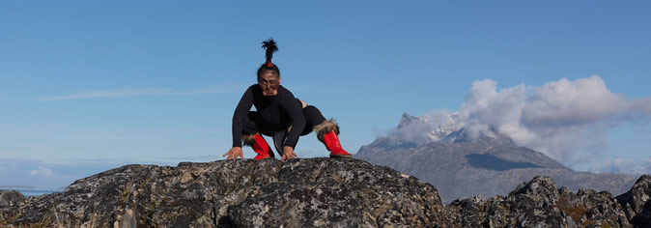

Beskrivelse af billede 1

Asseq 1-ip allaaserinera

________________________________________________________________________________________________________________________________________________________________________________________________________________________________________________________________________________________________________________________________________________________________________________________________________________________________________________________________________________________________________________________________________________________________________________________________________________________________________________________________________________________________________________________________________________________________________________________________________________________________________________________________________________________________________________________________________________________________________________________________________________________________________________________________________________________________________________________________________________________________________________________________________________________________________________________________________________________________________________________________________________________________________________________________________________________________________________________________________________________________________________________________________________________________________________________________________________________________________________________________________________________________________________________________________________________________________________________________________________________________________________________________________________________________________________________________________________________________________________________________________________________________________________________________________________________________________________________________________________________________________________________________________________________________________________

Billede 2
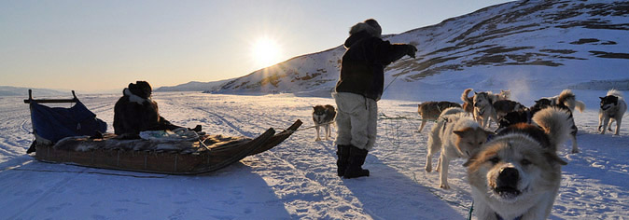

Billede 3

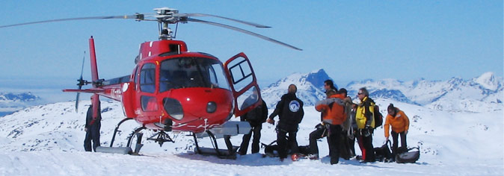

Beskriv hvad du ser på billede 2 og 3
Asseq 2-mi aamma 3-mi takusatit allaaserikkit
________________________________________________________________________________________________________________________________________________________________________________________________________________________________________________________________________________________________________________________________________________________________________________________________________________________________________________________________________________________________________________________________________________________________________________________________________________________________________________________________________________________________________________________________________________________________________________________________________________________________________________________________________________________________________________________________________________________________________________________________________________________________________________________________________________________________________________________________________________________________________________________________________________________________________________________________________________________________________________________________________________________________________________________________________________________________________________________________________________________________________________________________________________________________________________________________________________________________________________________________________________________________________________________________________________________________________________________________________________________________________________________________________________________________________________________________________________________________________________________________________________________________________________________________________________________________________________________________________________________________________________________________________________________________________________________________________________________________________________________________________________________________________________________________________________________________________________________________________________________________________________________________________________________________________________________________________________________________________________________________________________________________________________________________________________________________________________________________________________________________________________________________________________________________________________________________________________________________________________________________________________________________________________________________________________________________________________________________________________________________________________________________________________________________________________________________________________________________________________________________________________________________________________________________________________________________________________________________________________________________

Opgave 2. Fri formulering:

Skriv om dine fremtidsdrømme:

Hvad vil du gerne arbejde med? Hvor vil du gerne bo? Har du familie eller vil du gerne have det?

Siunissami angorusutatit allaaserikkit:
Sumut tunngasumik suliaqarusuppit? Sumi najugaqarusuppit? Sumi ilaqutaqarpit imaluunniit sumi ilaqutaqalerusuppit?
________________________________________________________________________________________________________________________________________________________________________________________________________________________________________________________________________________________________________________________________________________________________________________________________________________________________________________________________________________________________________________________________________________________________________________________________________________________________________________________________________________________________________________________________________________________________________________________________________________________________________________________________________________________________________________________________________________________________________________________________________________________________________________________________________________________________________________________________________________________________________________________________________________________________________________________________________________________________________________________________________________________________________________________________________________________________________________________________________________________________________________________________________________________________________________________________________________________________________________________________________________________________________________________________________________________________________________________________________________________________________________________________________________________________________________________________________________________________________________________________________________________________________________________________________________________________________________________________________________________________________________________________________________________________________________________________________________________________________________________________________________________________________________________________________________________________________________________________________________________________________________________________________________________________________________________________________________________________________________________________________________________________________________________________________________________________________________________________________________________________________________________________________________________________________________________________________________________________________________________________________________________________________________________________________________________________________________________________________________________________________________________________________________________________________________________________________________________________________________________________________________________________________________________________________________________________________________________________________________________________

