Piareersarfik
Kalaallisut misilitsinneq AEU 2 (sillimmat/reserve)
Sap. Ak. 3. 2013
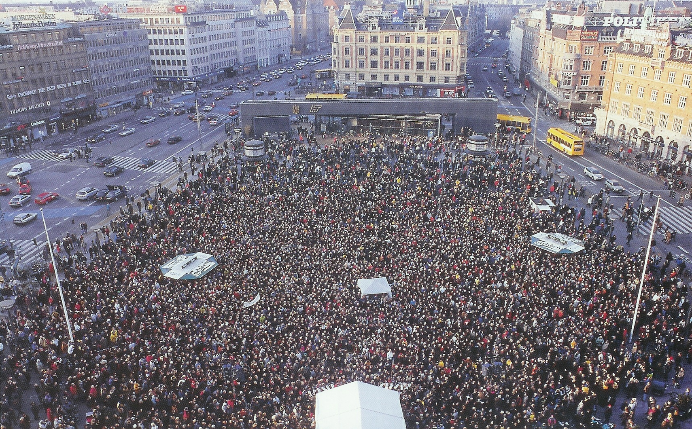
Suliassiissutit sisamaapput: Tamarmik akineqassapput
Ulloq misilitsiffik: 17. Januar 2013
Piffissami nal. Ak. 09.00-09.30 Eqimattakkaarluni oqaloqatigiinneq
09.45-12.00: Kisimiilluni allaaserinninneq
Ikiuutissat: Ordbogit: Oqaatsit – kalaallisut/qallunaatut
Misilitsinnerup sivisussusia/ Varighed 3 timer

Atuartup aqqa/ Elevens navn:_____________________________________________
Cpr.nr.:______________________________________________________________
Piareersarfik:__________________________________________________________
Nakkutilliisup atsiornera: Prøvevagtens underskrift:___________________________________________________
Piffissaq tunniussiffik / Tidspunkt for aflevering:______________________________________________________
Suliassaq 1
Sinnattuinnarnerlunga naluara.

Inuusuttuaraallunga ulloq kungit-pingasut angerlarpunga unnuap-qiteqqutilernerani.
Aqagumut atuartussaangatta suli qitittoqaraluartoq, nuannarinngikkaluarlugu ”angerlajaarnera”, angajoqqaamma unnuap-qeqqanut angerlareersimaqqummannga angerlarpunga.

Iserama angajoqqaakka qatanngutikkalu nukarliit sinilereersimapput. Tiiliuussinnarlunga tiitorpunga. Qalianut innariartorama atisakka piiarsinnarlugit innarpunga.

Innatsiaannarlunga sinnattulerpunga. - Sinnattorilerpara taamani Aasiaat oqaluffiani sianertartuusup itersariartorlunga Tipituup qaavanit ammut ingerlasoq sinnattoralugu.

Ammut aqqusinikkut ingerlagami, uatsinnut iserami, majuartarfitsigut majuarami, sinittarfimmut iserami tuikkut attorlunga itersarpaanga.

Itertungalu pilerpaanga: ”Aangikkinuna palasip aaqqummatit. Naalagiarniartunut ikiuukkiartorinngooq.” Akuersaarpara.

Akuersaarinnilu aterami anerpallappoq. Animmat atisalersorsinnarlunga Tipituumiik oqaluffitoqqap tungaanut ingerlalerpunga. Issippoq. Oqaluffitoqaq taamani atorunnaareernikuuvoq.

Tikiutileriallarama taanna sianertartoq siuninni. Oqaluutilerpaanga - ”oqaluffiup naliginnaasumik isertarfiatigut isernak, oqaluffiulli kangiatungaatigut isertarfikkut isissasuutit.”

Tassuuna iseriallarama oqaluffiup ilua tamarmi taartuinnaasoq, alterip iluani naneruutit kisimik ikumallutik.

Palasip tikilluaqqullunga pilerpaanga: ”Pattagiaq saneraatigut ”tukkarfeqarmat” aatippakkit pattaleruma ”tukkartoriniassagakkit”. ”

Oqaluffiup ilua tamarmi tarrajuttuinnaavoq, kisianni oqaluffiup issiavii tamakkerlutik inunnik qaqortumik uligualinnik ulikkaarpoq.

Issiavissannut innersuummanga ingippunga, kisianni ”naalagiartut” qissimigaaqqunngilai. Toqoreersimasunngooq naalagiarmata inuttassarsiussannginnakkit.

Naalagiarneq sivikitsuinnaavoq. Tussiutit pingasut atorpaat. ”Soraarmata” palasip iserfigisakkut anisippaanga. Sinilluaqqusinnarlunga matu matungaalu angerlarlunga aallarpunga.

Angerlamut ingerlangama allanik inussinngilanga. Uatsinnut iserama atisakka qalliit peerakkit, qalianut majuarama innarpunga. Innarlungalu ”sinnattunniik” iterpunga. Uannut maluginialerpunga timera tamarmi nillertuinnaasoq, soorlu silamiit aatsaat iserlunga innarsimasunga.

Sinnartorisara ersareruttormat ulloq manna tikillugu piviusuunersoq piviusuunnginnersorluunnit nalileruminaatsippara.

Angutiviaq Joelsen
11. november kl. 23:47 2012
Tigusiffik. http://www.facebook.com/groups/446739605378225/

Suliassaq 2
- Allaatigisamit apeqqutit akikkit.
- Ulloq suna qitittoqarpa?
____________________________________________________________________________________________________________________________________________________________________________________________________________________________________________________________________________________________________________________________________________________________
2. Sooruna angerlajaartoq? ________________________________________________________________________________________________________________________________________________________________________________________________________________________________________________________________________________________________________________________________________________________________________________
3. Sinnattumini kimit aatippa?
________________________________________________________________________________________________________________________________________________________________________________________________________________________________________________________________________________________________________________________________________________________________________________
4. Sinnattumini sumut ingerlava?
________________________________________________________________________________________________________________________________________________________________________________________________________________________________________________________________________________________________________________________________________________________________________________

5. Sooruna palasip aatikkaa?
________________________________________________________________________________________________________________________________________________________________________________________________________________________________________________________________________________________________________________________________________________________________________________
6. Oqaluffiup iluani kikkut isersimappat?
________________________________________________________________________________________________________________________________________________________________________________________________________________________________________________________________________________________________________________________________________________________________________________
7. Sinnattuminit iterami qanoq imminut malugiga?
________________________________________________________________________________________________________________________________________________________________________________________________________________________________________________________________________________________________________________________________________________________________________________

Suliassaq 3
- Ilanngutassiaq atuaruk

Ilanngutassiaq – illarlutit peqqissarit
“Grin dig sund” Anette Kjærgaardmit allataq, Filters MedieBureau. Karen Ramsøemit nutserneqartoq.

Inuit 10.000 illarnerup ulluani Københavnimi illaqatigiittut. Rekordbogimi illaqatigiit amerlanerpaat illaqatigiinneranni 2000-mi assilisaq
Tigusiffik: http://www.latterinstituttet.dk/wp-content/uploads/2008/08/latterens-verdensdag1.jpg

Illarlutit peqqissarit
Illarujussuarnermi akornutaasinnaasut ikittuinnaapput. Tassami, anernissaaruttoqarsinnaammat kingutaasalluunniit iisoorneqarsinnaammata. Kisianni tassa illarneq timimut tarnimullu peqqinnartuuvoq.
Ha, ahar, har, har, hahr, ahar, ha! Inuit amerlanerit nalunngilaat illarnerup timimut sunniuttarnera, nunusinnaajunnaarluni illalernermi qulliit kuulertarput.
Ilaatigut illartarpugut illarnartumik misigisaqaraagatta, imaluunniit tusagaqaraagattta. Ilaatigut iluamilluunniit tunngavissaqarata illalertarpugut. Ilaatigut pissangalluta qasuallaarlutaluunniiit illalersinnaasarpugut.
Sunaluunniit pillugu illaraluarutta timitsinnut tarnitsinnullu illarneq peqqinnaartuusoq ullutsinni misissuinerit takutippaat. Illarnermik katsorsaasartoq illartitsisartorlu Hanne Gottlieb malissagutsigu, ullormut illarnerusariaqarpugut.
- Inuunerit, nunarsuarmut isiginneriaatsillu oqinnerulersisinnaavatit illarnikkut. Soorlu immaqa ulloq aallartittarukku illarlutit, taava imminut illersuutilersimassaatit ullup sinnerani misigisassannut nuanniitsunut. Illarnerpit misigitilissavaatit pitsaanerusumik ullormi ajornartorsiutinut soqutaavallaanngitsunit sunnertinnissat annikillisillugu. Hanne Gottlieb oqarpoq.
…
Illarneq ilorrisimaartitsilersarpoq Hanne Gottlieb ullormut minnerpaamik 10 minutsi illartarpoq, taamaaliortarporlu inuunerissaarnerujumalluni qiimanini inuunermillu isiginninnini nukitsorsarusullugit.
“Illaraagatta ilorrisimaarnerulersarpugut qasukkarsimaarnerulersarlutalu, pissutigalugu sukaqqanerit nukiillu qasukkartinneqartarmata, kiffaanngissuseqartutut misigisimalertarpugut.” Hanne Gottlieb oqarpoq.
Timerput illaraagatta endorfinernik sanasarpoq. Timitsinnut eqqissititsisartumik immitsinnullu naammagisimaalertarpugut.…
Nammineq oqarpoq inuunini qaamanerulersimasoq oqinnerulerlunilu, illarneruleraagami iluaagisai ikinnerulertarput. Taakku pilerput ukiorpaaluit matuma siorna illarnerup iluatannartuanut uisinneqarami.
- Inuttut nammineq misigisimasarpunga artorsarlunga akisussaaffinnillu nuanniitsunik peqarlunga, ilukkullu sorsuuteqartarpunga naammagisimaarusullunga. Taamaallunga ukioq sivisooq oqimaatsorlu ingerlareersoq avisimi takulerpakka indiamiut 15.000-it illarnerup ulluani, tassanngaaniillu ineriartorneq pitsaasoq aallartippoq.
Hanne Gottliebip illarnerup iluaqutai peqqissiartornartuilu taassumallu kinguneraa ullumikkut illarnerup inuuniutigilerneranik.
Ajornartorsiutit illaatigikkit. Illarnermut ilitsersuisutut inuit tusindilikkaat illaqatigisimavai suliffeqarfinni, allaffeqarfinni klubbini, inuinnaallu festerfiini. Amerlasuut aallaqqaammut illarniarsarineq misigisarpaat ilumuunngitsutut. Kisianni Hanne Gottliebib arpannermut assersuuppaa.
- Arpakkutta illaruttaluunniit ilutsinni allannguuteqartikkusuttarparput, ilorrisimaarnerulerluta timerpullu nukitsorserlugu.
Hanne Gottlieb isumaqarpoq ullup ingerlanerani illarnerusariaqartugut, pausernermi illarnartoqartittarlugu. Inuit suliaminnut piumasaqarfiusunut ulapiffiusunullu illuatugiliuttutut.
- Ilaquttagut suleqatigulluunniit illaqatigisimagutsigit nuanniilliulinnginnissaq pineqarsinnaavoq.
Sooq aamma suna tamaat oqimaatsumik isigissavarput? Hanne Gottlieb aperivoq. Nassuiarlugulu illarutta ajornartorsiutit allaanerusumik isigilissagivut, sapinngikkutta illaatiginissaanut.
- Illaraagatta, ajornartorsiutit minnerulersutut ilisarput, pissutigalugu ernumaneq illarnermik nuannersumik taarserneqartarmat. Ajornartorsiullu ungasianiit isigisutut ilertarparput, aamma ajornartorsiummut aaqqiissutissamik nassaartartugut, Hanne Gottlieb isumaqarpoq.
- Kingumummi qiviarutta piviusumik ajornartorsiutit annikitsuararsuusarput.
… Tigusiffik http://www.latterinstituttet.dk/latterinstituttet/artikel-grin-dig-sund/

Suliassaq 4
- Illarluarsimatillutit qanoq misigisarnerit aammalu illartarnerup inummut sunniutigisartagai isummersorfigikkit
____________________________________________________________________________________________________________________________________________________________________________________________________________________________________________________________________________________________________________________________________________________________________________________________________________________________________________________________________________________________ ________________________________________________________________________________________________________________________________________________________________________________________________________________________________________________________________________________ ________________________________________________________________________________________________________________________________________
________________________________________________________________________________________________________________________________________ ________________________________________________________________________________________________________________________________________________________________________________________________________________________________________________________________________________ ________________________________________________________________________________________________________________________________________________________________________________________________________________________________________________________________________________ ____________________________________________________________________________________________________________________________________________________________________________________________________________________________________________________________________________________________________________________________________________________________________________________________________________________________________________________________________________________________________________________________________________________________________________________________________________________________________________________________________________________________________________________________________________________________________________________________________________________________________________________________________________________________________________________________________________________________________________________________________________________________________________________________________________________________________________________________________________________________________________________________________________________________________________________________________________________________________________________________________________ ________________________________________________________________________________________________________________________________________________________________________________________________________________________________________________________________________________________________________________________________________________________________________________________________________________________________________________________________________________________________________________________________________________________________

