Piareersarfik
Kalaallisut misilitsinneq AEU 2 (Atuuttussaq/Ordinær)
Sap. Ak. 14. 2013
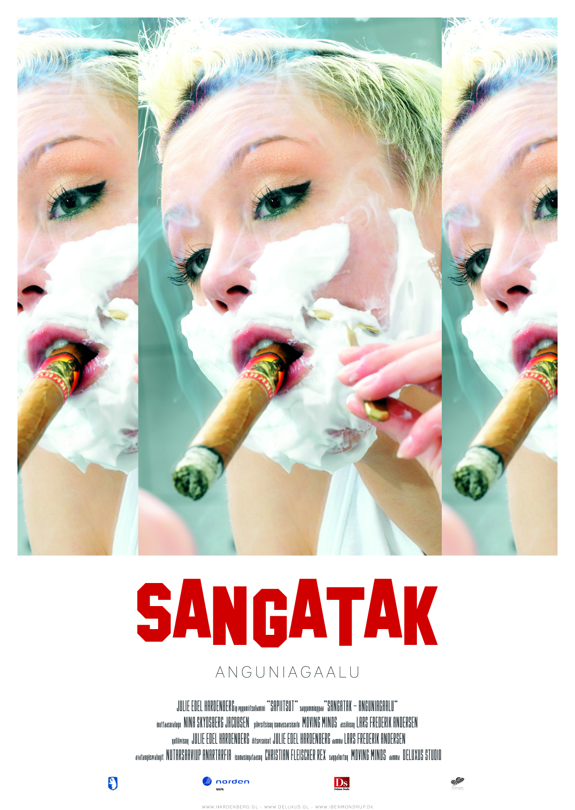
Suliassiissutit tallimaapput: Tamarmik akineqassapput
Ulloq misilitsiffik: 5. April 2013
Piffissami nal. Ak. 09.00-09.30 Eqimattakkaarluni oqaloqatigiinneq
09.45-12.00: Kisimiilluni allaaserinninneq
Ikiuutissat: Ordbogit: Oqaatsit – kalaallisut/qallunaatut
Misilitsinnerup sivisussusia/ Varighed 3 timer

Atuartup aqqa/ Elevens navn:_____________________________________________
Cpr.nr.:_________________________________________
Piareersarfik:____________________________________
Nakkutilliisup atsiornera: Prøvevagtens underskrift:___________________________________________________
Piffissaq tunniussiffik / Tidspunkt for aflevering:______________________________________________________
Suliassaq 1
- Oqaluttualiaq atuaruk
Aamma uagut taamaappugut?
Illut qisuinnannguit ataaserlu issunik ujaqqanillu qarmaqartoq tamarmik alinnartuunngivissut (takuminanngivissut) eqimmallutik ippiup qaani narsartami toqqissumiipput. Ilaat sanimikkut karsimut angisuumut eqqaanarnerusunik queqarput ikaartarfilinnik. Ikaani kalaalimernit piniutillu nivingapput. Illut akornini aqqusineerannguit nalunaaqaat, nuna kinguaariippassuit kamiinit manngertigulluni aqqusininnguussimasoq.
Illut taakku eqqaanni immikkuullarillutik illut allat alinnarnerullutillu (kusanarnerullutillu) takuminarneroqisut napapput. Siullernut naleqqiullugit illorsuarnik taasariaqarnerupput. Qalipaatigissaartuupput igalaartuullutik silatimikkullu ungaluukkersukkanik naatsiiveqarlutik. Aasaanerani naasut tamalaat alutornartut ilaatigullu ruuat naatsiivinni taakkunani naatinneqartarput silataaniit isigalugit takuminavissarlutik.
_ _ _
Illorsuup annerpaap silataani naatsiiverujussuup iluani meeqqat pingasut akutakujuuginnaat naasorpassuit qalipaatigissaartut akornanni pinnguarput paasissaanngitsunik oqalullutik. Aasarilluni seqinnarisseruttorsimavoq inneruulat tamani tamaani sivinganinnguani ivigarissuni qinngorlutik, kangerlunnguit qatsunganermit qillariinnaallutik, akiani qaqqarsuartigut kuuit kuuppaluat tikiumisaarluni.
Meerarpaaluit simaartuinnaat qernariinnarnik nujallit illorsuup eqqaani 2 oorimoorlutik 5 oorimoorlutillu nalluutereersimallutik naatsiivimmi inuaqerpaluleriarmat ussagalerput. Naatsiiviup ungaluisa qisuusut portusuut manngui ivigarsuarnik naaffigisimasut silaterpiannguannut qeqqerarlutik akutaaqqat naatsiivissuarmi pinnguartut isiginnaalerpaat. Amerlanerit annoraaminiinnannguanik igalaasalinnik annoraaqarput qarlissianik issukullannik qarleqarlutik. Ilaat tujuuluinnaapput qaatigut ujatsiuteqarlutik. Amerlanerit ipiitsuinnaanngivipput ilaasalu ikusii, nului seeqquilu ilaartornikuullutillu nutaamik alinneqartiterput iluatigut atisaat ilullissiat ersiallattarlutik.
Akutaaqqat uku atisarissaavipput kamippaqarlutik akutaanertillu ilaarlugu qasaartuinnavissuullutik. Pinngussanik ilaatigut qaqutiguuissunik pinngualersorlutik pinnguartut simaartuaqqat silataaniit isiginnaarrappaat ilaasa kaasarfisik kaallugit kakkitik millutillattaarlugit. Kisiinnerusortaat (sapiinnerusortaat) ilaanneeriarlutik ilummut suaartartarput ilassiuillutillu, akutaaqqallu silammut qiviartarlutik illartarput silatiminniittullu ilaat kakkilertarnerinik ussersuuttarlugit. Taava silataanniittut tamarmik illarratinnguallaaraat.
Pillingajaanaasiit quiasunniarumatuut ilaat ilummut ujaqqamik miloriarmat ilai kakkagiummersimanerlugu illarratileqaat. Akutaaqqalli ujarak eqqaminnut tuttoq takullugu annuliutereerlugu qiviarput tikertillu kivillugu ileqimisaartorlutik oqaloriarlutik peeqqusillutik usseralerlutik oqarniarlutillu: ”Peerit”. Taamaaleriarmata simaartuaqqat akunnattuungalerlutik illarunnaarput ilaasalu miloriartoq tikkuartorlugu oqalulerput: ”Unaana”. Akutaaqqalli peeqqusillutik usseraaginnarput qungujulaniarunnaavillutillu. Simaartuaqqat ungalut qimalaarlugit tunuarteraluariarlutik unipput kinguninngualu sassarteqqeriarlutik ungalunut miluutsiteqqillutik (talillutik). Akutaaqqat qaqutiguinnaq qissimittarlutik pinnguaqqilerput ruuanillu nususseriarlutik nerisarlugit.
Simaartuaqqat ilaat ipikujuttoq alinnikunik qarlilik taamaalluni kaasarfissoriarami ooriutimi ilaat ilummut miloriuppaa akutaaqqat killinnguannut tutsillugu. Taamaaleriarmat ilai tamangajammik oorinik ilummut milluulerput. Marlussuit kisimik taamaaliunngillat ilatillu oqaluullugit isumalukaseqimmata tunioraqqunagit. Kisiannili akutaaqqat ikinngutinnersumik kiinnerlutik illartarlutik sikisaarlutillu oorinik katersuilerallartillugit ilai millooraluttuinnarput. Milloorumanngitsut aappaa oqarpallappoq: ”Tamakku amigaatiginngilaat, tuniorarnagit, kanngunaannarpusi.” Milloortulli ilaata akivaa: ”Ilagiumaneq ajormatsit sinnganak, naalakkumaneq-una ajorakkit ilagiumaneq ajoraatsit. Oorinik millooruit kammattaarissavaatsit. Milloorniakkit, akimaniarpallaarnak.” Akerliusortaat qimagukkiartuutigaluni oqaannarpoq: ”Qallunnerituallaarasi! Kummiinnaqarpusi!”
Qimatai ilaatigut allunaasanik ujatsiutillit ikusii, nului seeqquilu alinneqartitertut illarlutik ooriutinnguaminnik ilummut milloortuarput nunguutsinissartik tikillugu. Akutaaqqalli kammalaatimaalivipput naggataagullu illorsuarmut isileramik sikisarlutik illarlutillu qujariarlutik ilaata ruuat marluk naatsiiviup silataanut ungalut qarsullugit miloriuppai. Aasiillimi simaartuaqqat pilernguttunnguupput, soorlumi naajat agiortut, akutaaqqat qitutsisingajallugit.
Tigulaariffik: ” Aamma uagut taamaappugut? V/Moses Olsen , ” Aperissagumma sooq allattartunga”… - Atuakkiorfik 1991”
Suliassaq 2
- Oqaluttualiamit apeqqutit akikkit.
- Illut qanoq ittuuppat?
________________________________________________________________________________________________________________________________________________________________________________________________________________________________________________________________________________________________________________________________________________________________________________
- Akutaaqqat sulerippat?
________________________________________________________________________________________________________________________________________________________________________________________________________________________________________________________________________________________________________________________________________________________________________________
- Simaartuaqqat suppat?
________________________________________________________________________________________________________________________________________________________________________________________________________________________________________________________________________________________________________________________________________________________________________________
- Piffissaq sunaava? Suut ilisarnaataappat?
________________________________________________________________________________________________________________________________________________________________________________________________________________________________________________________________________________________________________________________________________________________________________________

- Simaartuaqqat akutaaqqanut akuereqqullutik qanoq pippat?
________________________________________________________________________________________________________________________________________________________________________________________________________________________________________________________________________________________________________________________________________________________________________________

Suliassaq 3
Oqaluttualiami sammisat pisullu isummersorfigikkit.
________________________________________________________________________________________________________________________________________________________________________________________________________________________________________________________________________________________________________________________________________________________________________________________________________________________________________________________________________________________________________________________________________________________________________________________________________________________________________________________________________________________________________________________________________________________________________________________________________________________________________________________________________________________________________________________________________________________________________________________________________________________________________________________________________________________________________________________________________________________________________________________________________________________________________________________________________________________________________________________________________________________________________________________________________________________________________________________________________________________________________________________________________________________________________________________________________________________________________________________________________________________________________________________________________________________________________________________________________________________________________________________________________________________________________________________________________________________________________________________________________________________________________________________________________________________________________________________________________________________________________________________________________________________________________________________________________________________________
Suliassaq 4
Nutaarsiassaq atuaruk
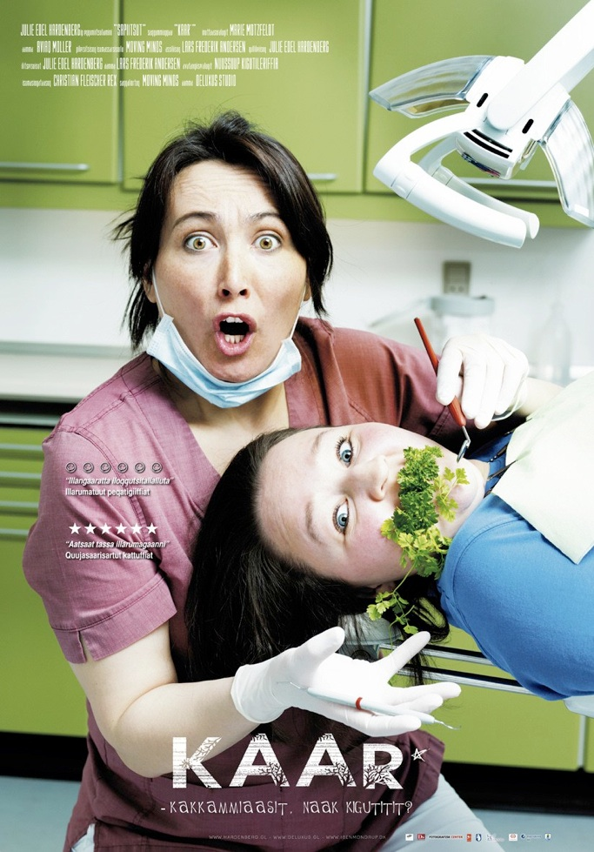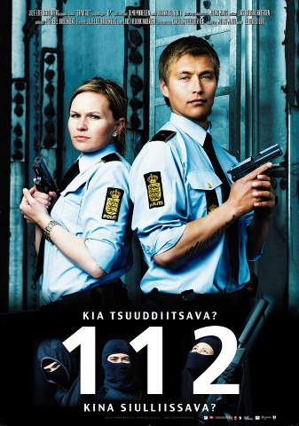
Julie Hardenbergip assit atorlugit suliai soorlu hollywoodiminngaanniiginnallartut

Kalaallit Nunaata sapiitsortai plakatiliarineqartut
Julie Edel Hardenbergip takorluukkat piviusunngortillugillusooq assit atorlugit suliai saqqummersinneqartut
Af redaktionen
08:16, 21. October 2011
Qanoq akulikitsigisumik kalaallit sapiitsut takusarpagut? Imaluunniit filmini akisoorsuarni pingaarnertut inuttaasarpat?
Apeqqut taanna Julie Edel Hardenbergip eqqarsaatersuutigisimavaa assinillu suliaq Sapiitsut/Heroes maannakkut saqqummersinneqartussaq pilersillugu.
Assiliisartoq Lars Frederik Andersen peqatigalugu plakatit 16-it suliarisimavai, amerikamiut europamiullu filmiliarisartagaasa ilisimalluakkatsinnut assingusunik tamaasa isikkulerlugit. Quiasaarisut, tiguaanernit filmiliat, paasunik filmiliat, asanninnilersaarutit aammalu meeqqanut naleqqussakkat. Filmilli tamakku ussassaarutigineqartut filmertarfinni takuneqarsinnaanngillat; piviusuunngimmata.
Eqqumiitsuliortup takorluukkat silarsuaat Hollywoodiminngaanneersoq atorlugu sapiitsunik pilersitsivoq. Kalaallit Nunaanni inuit nammineq nuannaartorineqarsorisani takutippai. Anartaajaasartoq, qatserisartoq, ilinniartoq inuusuttoq, aataq aamma erngutaq, ikinngutigiit inuppassuillu allat nalinginnaasumik kalaallit isigineqartarnerannit allaanerusut. Aammalumi immaqa sapiitsunik takorloortakkanit allaanerusut.
Saqqummersitsineq Iben Mondrupimit aaqqissuunneqarlunilu akisussaaffigineqartoq Katuami oktobarip 28-annit 2011 novembarip 13-iannut takuneqarsinnaavoq aammalu Fotografisk Centerimi novembarip 25-annit 2011 januaarip arfineq-aappaa 2012.
Fotografisk Center, Carlsbergip maqitsivigisimasaani tapperihallernimi Vesterbromiittumiippoq

Tigulaariffik http://sermitsiaq.ag/kl/node/110290

Suliassaq 5
- Julie Edel Hardenbergip plakatiliaai nalilersukkit. Qanormita issagaluarpa kalaallit nunaanni filmiliat amerligaluarpata. Plakatit filmilluunniit kalaallinut tunngasut takunikuusatit isumassarsiorfigisinnaavatit.
____________________________________________________________________________________________________________________________________________________________________________________________________________________________________________________________________________________________________________________________________________________________________________________________________________________________________________________________________________________________ ________________________________________________________________________________________________________________________________________________________________________________________________________________________________________________________________________________ ________________________________________________________________________________________________________________________________________________________________________________________________________________________________________________________________________________ ________________________________________________________________________________________________________________________________________________________________________________________________________________________________________________________________________________ ________________________________________________________________________________________________________________________________________________________________________________________________________________________________________________________________________________ ____________________________________________________________________________________________________________________________________________________________________________________________________________________________________________________________________________________________________________________________________________________________________________________________________________________________________________________________________________________________________________________________________________________________________________________________________________________________________________________________________________________________________________________________________________________________________________________________________________________________________________________________________________________________________________________________________________________________________________________________________________________________________________________________________________________________________________________________________________________________________________________________________________________________________________________________________________________________________________________________________________ ________________________________________________________________________________________________________________________________________________________________________________________________________________________________________________________________________________________________________________________________________________________________________________________________________________________________________________________________________________________________________________________________________________________________

