Piareersarfik
Kalaallisut misilitsinneq AEU 2 (Sillimmat/Reserve)
Sap. Ak. 33. 2013

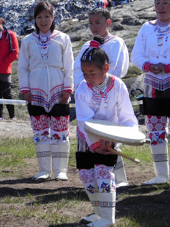
Suliassiissutit sisamaapput: Tamarmik akineqassapput
Ulloq misilitsiffik: 16 August 2013
Piffissami nal. Ak. 09.00-09.30 Eqimattakkaarluni oqaloqatigiinneq
09.45-12.00: Kisimiilluni allaaserinninneq
Ikiuutissat: Ordbogit: Oqaatsit – kalaallisut/qallunaatut
Misilitsinnerup sivisussusia/ Varighed 3 timer

Atuartup aqqa/ Elevens navn:_____________________________________________
Cpr.nr.:_________________________________________
Piareersarfik:____________________________________
Nakkutilliisup atsiornera: Prøvevagtens underskrift:___________________________________________________
Piffissaq tunniussiffik / Tidspunkt for aflevering:______________________________________________________
Suliassaq 1
- Nutaarsiassaq atuaruk
TASIILAMI INUIATTUT ULLORSIORNEQ

Tasiilami juunip 21-ani inuiattut ullorsiornermi inuit makiaartarput. Tamanna takornartaavallaarunanngilaq.
Sunngiffimmi Sammisaqartitsisut ullormut sammisassat tamaasa aaqqissuuttarpaat, ilaatigut ullaaralaakkut nalunaaqutaq arfineq-marluniit umiatsiamik angoqqaanniunneq ingerlanneqartarpoq. Puisimik tikiusseqqaartut akissarsitinneqartarput, puisit pisarineqartut ualikkut Iddimiiniinnermi pilanneqartarlutik.
- Tasiilami inuiattut ullorsiornermi illoqarfiit allat assigalugit ullaakkut arfineq-pingasunut aappalaartulernermik, qamutilittarnermik oqalugiarnermillu ulloq aallarnerneqartarpoq, soorunami erinarsoqatigiit aallarneeqataasarput. Tamanna illoqarfiup qeqqani kommunip allaffiata eqqaani pisarpoq, ullaaq taanna aamma takkutunut kaffeqarluni, teeqarluni aamma poor´loqartarpoq, taama sunngiffimmi sammisassaqartitsinermik pisortaq Harald Bianco oqaluttuarpoq.
Sinerissami pisartut assigalugit nalunaaqutaq qulingiluanut naalagiartoqartarpoq, naalagiaqatigiinneq naammassigaangat oqaluffiup silataaniittoq kisaq; imaatigut ajunaarsimasut eqqaassutissaat kransilerneqartarpoq tussiarfigineqarlunilu.
Tamatuma kingorna iliveqarfimmut ingerlaaqatigiittoqartarpoq tassanilu aamma kransiliisoqartarluni.
- Nuannarineqanerpaajulluni peqataaffigineqarnerpaajusarpoq ualikkut nalunaaqutaq ataatsinut aallartitumik Iddimiini katerisimaartarneq. Oqaatigineqassaaq ullaamiit unnummut programmi kalaallisut, qallunaatut tuluttullu naqinneqartarmat. Tassani takornarissat nunani allaneersut malinnaanissaat pinerullugu. Programmi takornariaqartitsivinnut Hotelinullu agguaanneqartarpoq. Iddimiinniinneq kalaallisut, qallunaatut tuluttullu oqaaseqarfiusumik ingerlanneqartarpoq, takornarissat eqqarsaatiginerullugit, Harald Bianco oqarpoq.
Iddimmiiniinnermi assigiinngitsorpassuarnik sammisaqartitsisoqartarpoq; ammaanerup kinguninngua umiaq qaannanik ingiartilik kalaallit tupiata ataanut tikittarpoq. Ullaajummat puisimik pisaqaqqaanniuunnermik pisarineqartut qaannat umiallu tikittut nassartarpaat. Toqqup eqqaani puisimik pilattoqartarpoq neqaanillu igasoqartarluni. Igaat takornarissanuunerusoq (misilitassanik) sassaalliutigineqartarput. Tassami Iddimiinnermi peqataasut namminneq kalaaliminerpassuarnik nassataqartarput, tamulugassat (mamartorsuarnik) ajornanngittaqaat. Harald Bianco oqaluttuarpoq.
Assigiinngitsunik; unamiuaarnerit arpannerit tivasunik takutitsinerit, kalattut arsarnerit allarpassuillu ualeq taama ingerlanneqarput.
Ulloq naggarserlugu innuttaasunut tamanut timersortarfimmi unnussiuaartoqartarpoq, assigiinngitsunik pisoqarfiusartumik.
Ukiut kingulliit amerlisut avataaniit, ingammik kitaaniit aliikkutassanut ilapittuutaasartunik nipilersortartunik qujanartaqisumik tikittoqallattaavoq. Soorlu aasaq manna 2013-imi NAIP-kkut kiisalu Zatikkut inuiattut ullorsiornitsinni maanissamaarput. Avataanit tikittut ingammik Iddimiiniinnermi unnukkullu timersortarfimmiinnermi akuulluartarput.
Tunumi Tasiilami suli inuiattut immitsinnut qanittutut annertuumik misigisimasarnerput ullormi tassani annertusarpoq qujamasunnartarlunilu. Sunngiffimmi sammisassaqartitsinermik pisortaq, Harald Bianco oqaluttuarpoq.

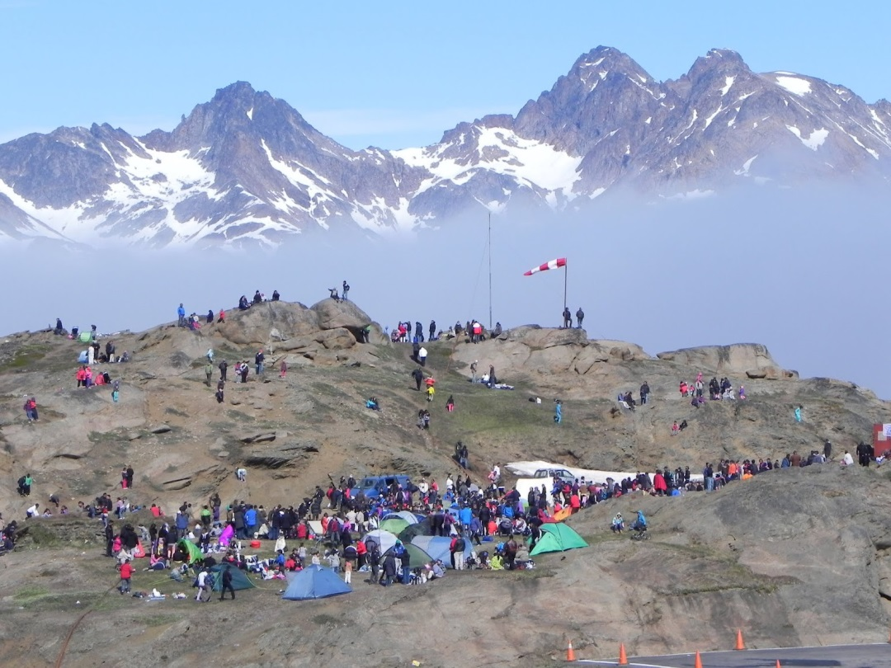
Suliassaq 2
- Oqaluttualiamit apeqqutit akikkit.
- Ullaakkut susoqartarpa?
________________________________________________________________________________________________________________________________________________________________________________________________________________________________________________________________________________________________________________________________________________________________________________
- Pisut sumi ingerlanneqartarpat?
________________________________________________________________________________________________________________________________________________________________________________________________________________________________________________________________________________________________________________________________________________________________________________
- Naalagiartoqareeraagat susoqartarpa?
________________________________________________________________________________________________________________________________________________________________________________________________________________________________________________________________________________________________________________________________________________________________________________
- Ullup ingerlanera oqaatsit suut atorlugit ingerlanneqartapa?
________________________________________________________________________________________________________________________________________________________________________________________________________________________________________________________________________________________________________________________________________________________________________________

- Aasaq manna 2013-mi susoqarniarpa?
________________________________________________________________________________________________________________________________________________________________________________________________________________________________________________________________________________________________________________________________________________________________________________

Suliassaq 3
Inuattut ullorsiornermi illit suut pingaartillugit peqataaffigisarnerlugit saqqummiigit.
____________________________________________________________________________________________________________________________________________________________________________________________________________________________________________________________________________________________________________________________________________________________________________________________________________________________________________________________________________________________________________________________________________________________________________________________________________________________________________________________________________________________________________________________________________________________________________________________________________________________________________________________________________________________________________________________________________________________________________________________________________________________________________________________________________________________________________________________________________________________________________________________________________________________________________________________________________________________________________________________________________________________________________________________________________________________________________________________________________________________________________________________________________________________________________________________________________________________________________________________________________________________________________________________________________________________________________________________________________________________________________________________________________________________________________________________________________________________________________________________________________________________________________________________________________________________________________________________________________________________________________________________________
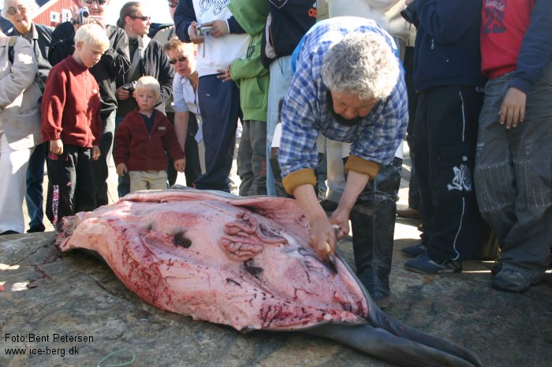
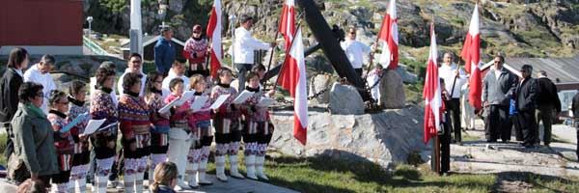
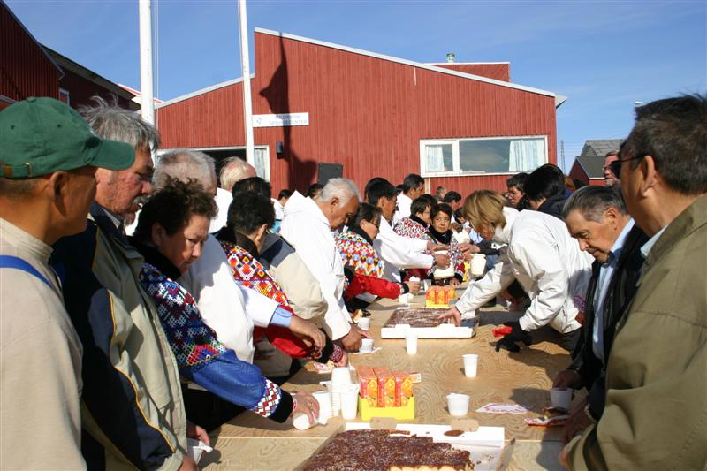
Suliassaq 4
- Assit aallavigalugit inuiattut ullorsiortarneq isummersorfigiuk.
____________________________________________________________________________________________________________________________________________________________________________________________________________________________________________________________________________________________________________________________________________________________________________________________________________________________________________________________________________________________ ________________________________________________________________________________________________________________________________________________________________________________________________________________________________________________________________________________ ________________________________________________________________________________________________________________________________________________________________________________________________________________________________________________________________________________ ________________________________________________________________________________________________________________________________________________________________________________________________________________________________________________________________________________ ________________________________________________________________________________________________________________________________________________________________________________________________________________________________________________________________________________ ____________________________________________________________________________________________________________________________________________________________________________________________________________________________________________________________________________________________________________________________________________________________________________________________________________________________________________________________________________________________________________________________________________________________________________________________________________________________________________________________________________________________________________________________________________________________________________________________________________________________________________________________________________________________________________________________________________________________________________________________________________________________________________________________________________________________________________________________________________________________________________________________________________________________________________________________________________________________________________________________________________ ____________________________________________________________________________________________________________________________________________________________________________________________________________________________________________________________________________________________________________________________________________________________________________________________________________________________________________________________________________________________________________________________________________________________________________________________________________________________________________________________________________________________________________________________________________________________________________

