Piareersarfik
Kalaallisut misilitsinneq AEU 2 (Atuuttussaq/Ordinær)
Sap. Ak. 21. 2013
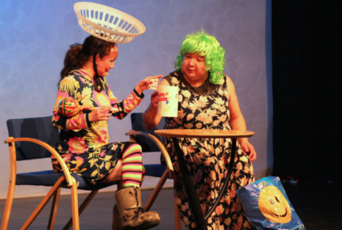

Suliassiissutit tallimaapput: Tamarmik akineqassapput
Ulloq misilitsiffik: 24 maj 2013
Piffissami nal. Ak. 09.00-09.30 Eqimattakkaarluni oqaloqatigiinneq
09.45-12.00: Kisimiilluni allaaserinninneq
Ikiuutissat: Ordbogit: Oqaatsit – kalaallisut/qallunaatut
Misilitsinnerup sivisussusia/ Varighed 3 timer

Atuartup aqqa/ Elevens navn:_____________________________________________
Cpr.nr.:_________________________________________
Piareersarfik:____________________________________
Nakkutilliisup atsiornera: Prøvevagtens underskrift:___________________________________________________
Piffissaq tunniussiffik / Tidspunkt for aflevering:______________________________________________________
Suliassaq 1
- Nutaarsiassaq atuaruk
( Ineriartorneq )

Tigulaariffik: ATUAGAGDLIUTIT/AG pingasunngorneq 31.oktober 2012

60-ikkut pequerfiusut
Piorsarsimassuseq/Kultur:

Nunarsuatsinni sumi tamani 1960-ikkut tassaapput inuusuttuni pikisitsiffiit, hippit, ikiaroorneq, Steppenwolf, flower power, Vietnamimi sorsunneq, arnat suliniaqatigiiffii pituttugaanngitsumillu atoqateqarsinnaaneq.
Aammami nunatsinni pisoqarfioqaaq, allaanerulaartumilli. Assersuutigalugu maani nangermik tunguusamik nasartaateqartoqaranilu/atuisoqaranilu meerarpassuit inunngoranngillat soorlu Danmarkimi taamaattoq. Sanaartornerujussuarli ingerlanneqarpoq aatsaallu taamak atortorissaarutinik akisuunik pisisoqartigisarluni soorlu qerititsivinnik qamuteralannillu. Qitigiarnissaminnik nuannarisallit Brylcreme (nujarissaat) peqqaannagu atortarpaat Beatlessikkut assigalugit nutsatik ilusilerniarlugit. Inuiaqatigiinni annertuumik allanngortoqarnera atuakkami nutaami ”Kalaallit Nunaat tressikkunnimi” kusanartumik allaaserineqarpoq Karen Tommerup Jensen aamma Bertil de Waal atuakkiortoralugit, Ilinniusiorfimmi saqqummeqqammersumi.
Atuakkat marluk naapertorlugit atuakkami anguniarneqarpoq ukiuni qulikkaani ilisarnaataasup siuariartornissamik pingaartitsinerup allaaserinissaa. Aamma atuartartut takusinnaalerpaat maannakkut ulluinnarsiutigisavut 1960-ikkunni qanoq nutaaliaallutillu pikkugineqartigisimanersut. Atuartartunut ukioqqortunerumaanut atuagaq eqqaakulunnissamut atorneqarsinnaavoq. Aammali kinguaariit inuusunnerusut ukiut nunatta nutaanngoriartulerfii pillugit annertunerusumik paasisaqarfigisinnaavaat.
- Atuagaq annermik piffissami tassani Atuagagdliutit/Grønlandspostenimi allaaserisaasimasut assilisallu tunngavigalugit suliaavoq. Allaaserisani siullerni nunatsinni aningaasaliinerujussuaq allaaserineqarpoq. Ukiuni sisamani naalagaaffik (DK) 2,4 milliarder koruuninik aningaasaliiniarpoq. 1969-imiinnaq sanaartornermut ingerlatsinermullu milliardip affaata tungaanut atorneqartussaapput. Sumi tamani inissiarsuit pinngorarput, talittarfiit , tunitsiviit, atuarfiit ingerlatsiviillu. 1962-imi AG-mi allaaserisami illoqarfiit pingaarnersaat sammineqarpoq qulequtaqartumi ” Nuuk alliartorluaqaaq”.
Nuuk ullut tamaasa allanngortarpoq, tusagassiortoq allappoq, kingornalu allaaseralugu siunissamut isumalluarneq annertooq sanaartornikkut sulianit annertuunit takuneqarsinnaasoq.
Ukiuni tulliuttuni Nuummi suliassat killeqanngingajapput. Illoqarfikulunngooriarluni anguniagaqartoq Nuuk pissutsinut piviusunut appakaannialerpoq. Ukiualuit qaangiuppata illoqarfinngussaaq mittarfilik, suliffissualik, aalisarnermut immikkoortoqarluni, namminersorlutik suliffeqarfiuteqartunut immikkoortortaqarluni Aahus Universitetilu assigalugu ilinniarferujussuaqarluni.
Siuttoq
Kalaallit Nunaannut ministereqarfimmi qallunaat atorfilittai siunissamut siulittuiniarsaripput. Innuttaasut illoqarfinnut inuiaqatigiinnut ikittunut ingerlalluartunullu katersuunnissaannik tamarmik immikkut takkorluugaqarput. Nuuk siuttuussaaq innuttaasut amerleriarujussuarlutik, ukiut qulikkaat arlaqartut qaangiuppata 6.000-iniit 25.000-inik inoqalissalluni.
Taamanikkulli ineriartupiloornerup unikaallannissaa ajornartorsiutaalereerpoq: Illoqarfimmi sulisussanik pissarsiuminaappoq. 1962-imi ima allaaserisaqartoqarsimavoq. – Kalaallinik ilinniarsimanngitsunik sulisussaaleqineq annertoqaaq. Tamanna inuiaqatigiit aningaasaqarnerannut akisullunilu assut uggorineqarpoq. Allaat talittarfimmi sulisussanik piffissap ilaani tikisitsisoqartarpoq. AG-mi tusagassiortoq allappoq.
Suliassat annertuut ilagaat inissaaleqinerujussuaq. – Nalunanngilaq ullumikkut Nuummi inissiani marlunnik initalinni inuit 20-t tungaannut najugaqarsinnaasartut. Inissianilu nutaani ineqarnermut aki qaffaseqaaq: Qaammammut 150 koruuneqarluni!
Siggunnut tarngutit atasinnaasut
60-ikkunni arnat suliartortalerput. Aalisakkerivinni suliffissarsisarput taamaalillutik meeqqamik paarineqarnissaat pisariaqartillugu. 1969-imi allaaserisami Narsami meeraaqqerivik allaaserineqarpoq. – Angajoqqaat meeqqamik paarineqarnerannut ullormut 3 koruunimik akiliisarput. Meeqqat ullaakkut takkukkaangamik meeraaqqeriviup atisaannik atisalertarput, taamaalillutik anaanaasut errorsisariaqaratik atisaallu nungullarnatik, allaaserisami allassimavoq. Arnat suliunnaaraangamik(soraaraangamik) niuertarfissuarni nutaani niuerniartarput. Marsimi 1969-imi Nuummi Brugseni ammarpoq. – Inuppassuillu isaapput. Inuit tattorliuupput paatsiveerusimaartoqarlunilu, AG-mi allaaserisami allassimavoq.
Kalaallit atuisartut periarfissat nutaat atorluapallappaat. Qerititsiviit, siggunnut tarngutit katanneq ajortut(læbestiftit), Ga-jolit, mersorfiit, nutsanut panersaatit, inuusat støvsugillu tunineqartarput. Decembarimilu 1964-imi qamuteralaat eqqunneqarput. – Taanna angallatissatuaavoq qimussimut nallersuussinnaasoq ilami immaqa suli pitsaanerulluni. Igalaaminiusamik oqquaquteqarnera(skærmeqarnera) motoorillu kissarnera pissutaallutik ingerlatitsisoq oqquusuni issiasarpoq, ussassaarummi allassimavoq.

Suliassaq 2
- Nutaarsiassamit apeqqutit akikkit.
- Nunarsuatsinni 1960-kkunni inuusuttut suut pikititsissutigivaat?
________________________________________________________________________________________________________________________________________________________________________________________________________________________________________________________________________________________________________________________________________________________________________________
- Kalaallit Nunaanni suut pippat?
________________________________________________________________________________________________________________________________________________________________________________________________________________________________________________________________________________________________________________________________________________________________________________
- Nuuk qanoq siuariartortinneqarpa?
________________________________________________________________________________________________________________________________________________________________________________________________________________________________________________________________________________________________________________________________________________________________________________
- Sanaartornerujussuaq qanoq ingerlasimava? Kikkullu sulisimappat?
________________________________________________________________________________________________________________________________________________________________________________________________________________________________________________________________________________________________________________________________________________________________________________

- Meeqqeriviguna sumiittoq oqaluttuarineqartoq? Qanoq oqaluttuarineqarpa?
________________________________________________________________________________________________________________________________________________________________________________________________________________________________________________________________________________________________________________________________________________________________________________

Suliassaq 3
Nutaarsiassami sammisat pisullu ullutsinnimut sanilliullugit isummersorfigikkit.
____________________________________________________________________________________________________________________________________________________________________________________________________________________________________________________________________________________________________________________________________________________________________________________________________________________________________________________________________________________________________________________________________________________________________________________________________________________________________________________________________________________________________________________________________________________________________________________________________________________________________________________________________________________________________________________________________________________________________________________________________________________________________________________________________________________________________________________________________________________________________________________________________________________________________________________________________________________________________________________________________________________________________________________________________________________________________________________________________________________________________________________________________________________________________________________________________________________________________________________________________________________________________________________________________________________________________________________________________________________________________________________________________________________________________________________________________________________________________________________________________________________________________________________________________________________________________________________________________________________________________________________________________________________________________________________________________________________________________________________________________________________________________________________________________________________________________________________________________________________________________________________________________________________________________________________________________________________________________________________________________________________________________________________________________________________________________________________________________________________________________________________________________________________________________________________________________________________________________________________________________________________________________________________________________________________________________________________________________________________________________________________________________________________________________________________________________________________________________________________________________________________________________________________________________________________________________________________________________________________________________________________________________________________________________________________________________________________________________________________________________________________________________________________________________________________________________________________________________________________________________________________________________________________________________________________________________________________________________________________________________________________________________________________________________________________________________________________________________________________________________________________________________________________________________________________________________________________________________________________________________________________________________________________________________________________________________________________________________________________________________________________________________________________________________________________________________________________________________________________________________________________________________________________________________________________________________________________________________________________________________________________________________________________
Suliassaq 4: Nutaarsiassaq atuaruk

Piitannguaq Marielu tissinaqaat
| 12:21 29. mar 2013 | 0 kommentarer

Kingulliarsussuaq Aapasoq - Piitannguup Mariellu quiasaarusiaat illariilingajatsitsivoq
Pingasunngormat unnukkut Katuami isiginnaartunik 500-nik ulikkaavissumi quiasaarisartut Piitanguaq Alaufesen aamma Marie Mathiassen isiginnaartitsipput.
Piitanguaq Alaufesen aallartippoq Qaanaarmiuusaarluni piniartoq isimi illuatigut 3D-qarluni.
Marie Mathiassen marlunnik takutitsivoq 'Aanakassaasaarluni' misilittagartooq nangillunilu ikinngutini eqiasuttoq nalunnguaqatiginiarlugu.
Piitanguaq Alaufesen ilisimaneqarluartutut isikkoqarluni nunaqarfinni sipaarniarnissat pillugit peqqaannagu quiasaaraluni.
Piitanguaq aamma Marie naggasiillutik isiginnaartitsipput aanaaq ernutaallu pissutsinik malinnaasut takutillugit.
Erland Olsen nipilersortuuvoq illartitsivissorlunilu aamma.
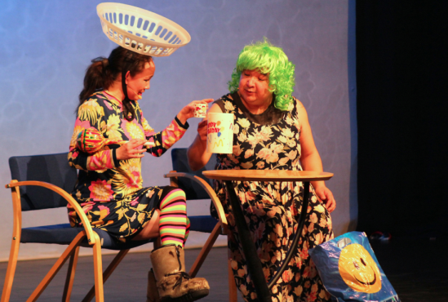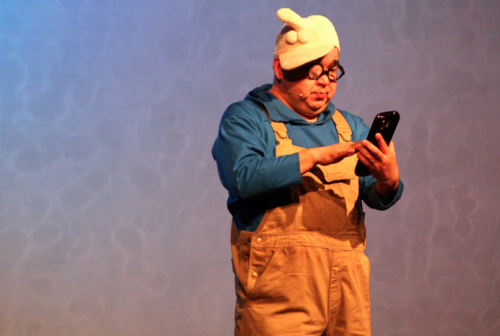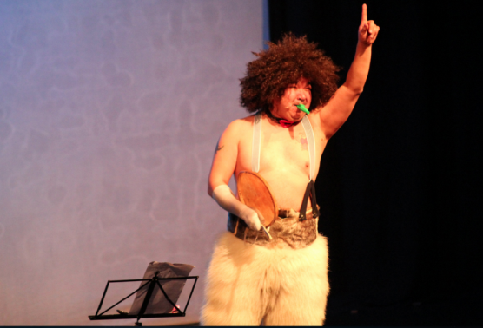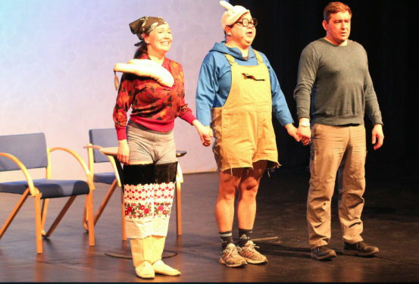
Marie Mathiassen, Piitanguaq Erlaufesen aamma Erland Olsen poorskikkunni isiginnaagassiami suliaqartuupput. Foto: Benny Kokholm
Tigusiffik: http://sermitsiaq.ag/node/150990
Suliassaq 5
- Ilanngutassiaq ”Piitannguaq Marielu tissinaqaat” qanoq igaajuk. Kalaallit Nunaanni isiginnaartitsisarneq isummersorfigiuk. Illarnerup inuunermut sunniuttarnera isumaliutersuutigiuk.
____________________________________________________________________________________________________________________________________________________________________________________________________________________________________________________________________________________________________________________________________________________________________________________________________________________________________________________________________________________________ ________________________________________________________________________________________________________________________________________________________________________________________________________________________________________________________________________________ ________________________________________________________________________________________________________________________________________________________________________________________________________________________________________________________________________________ ________________________________________________________________________________________________________________________________________________________________________________________________________________________________________________________________________________ ________________________________________________________________________________________________________________________________________________________________________________________________________________________________________________________________________________

